Advanced Higher Computing Science

Rage inciting square game

**Project 2024**

**Name**:

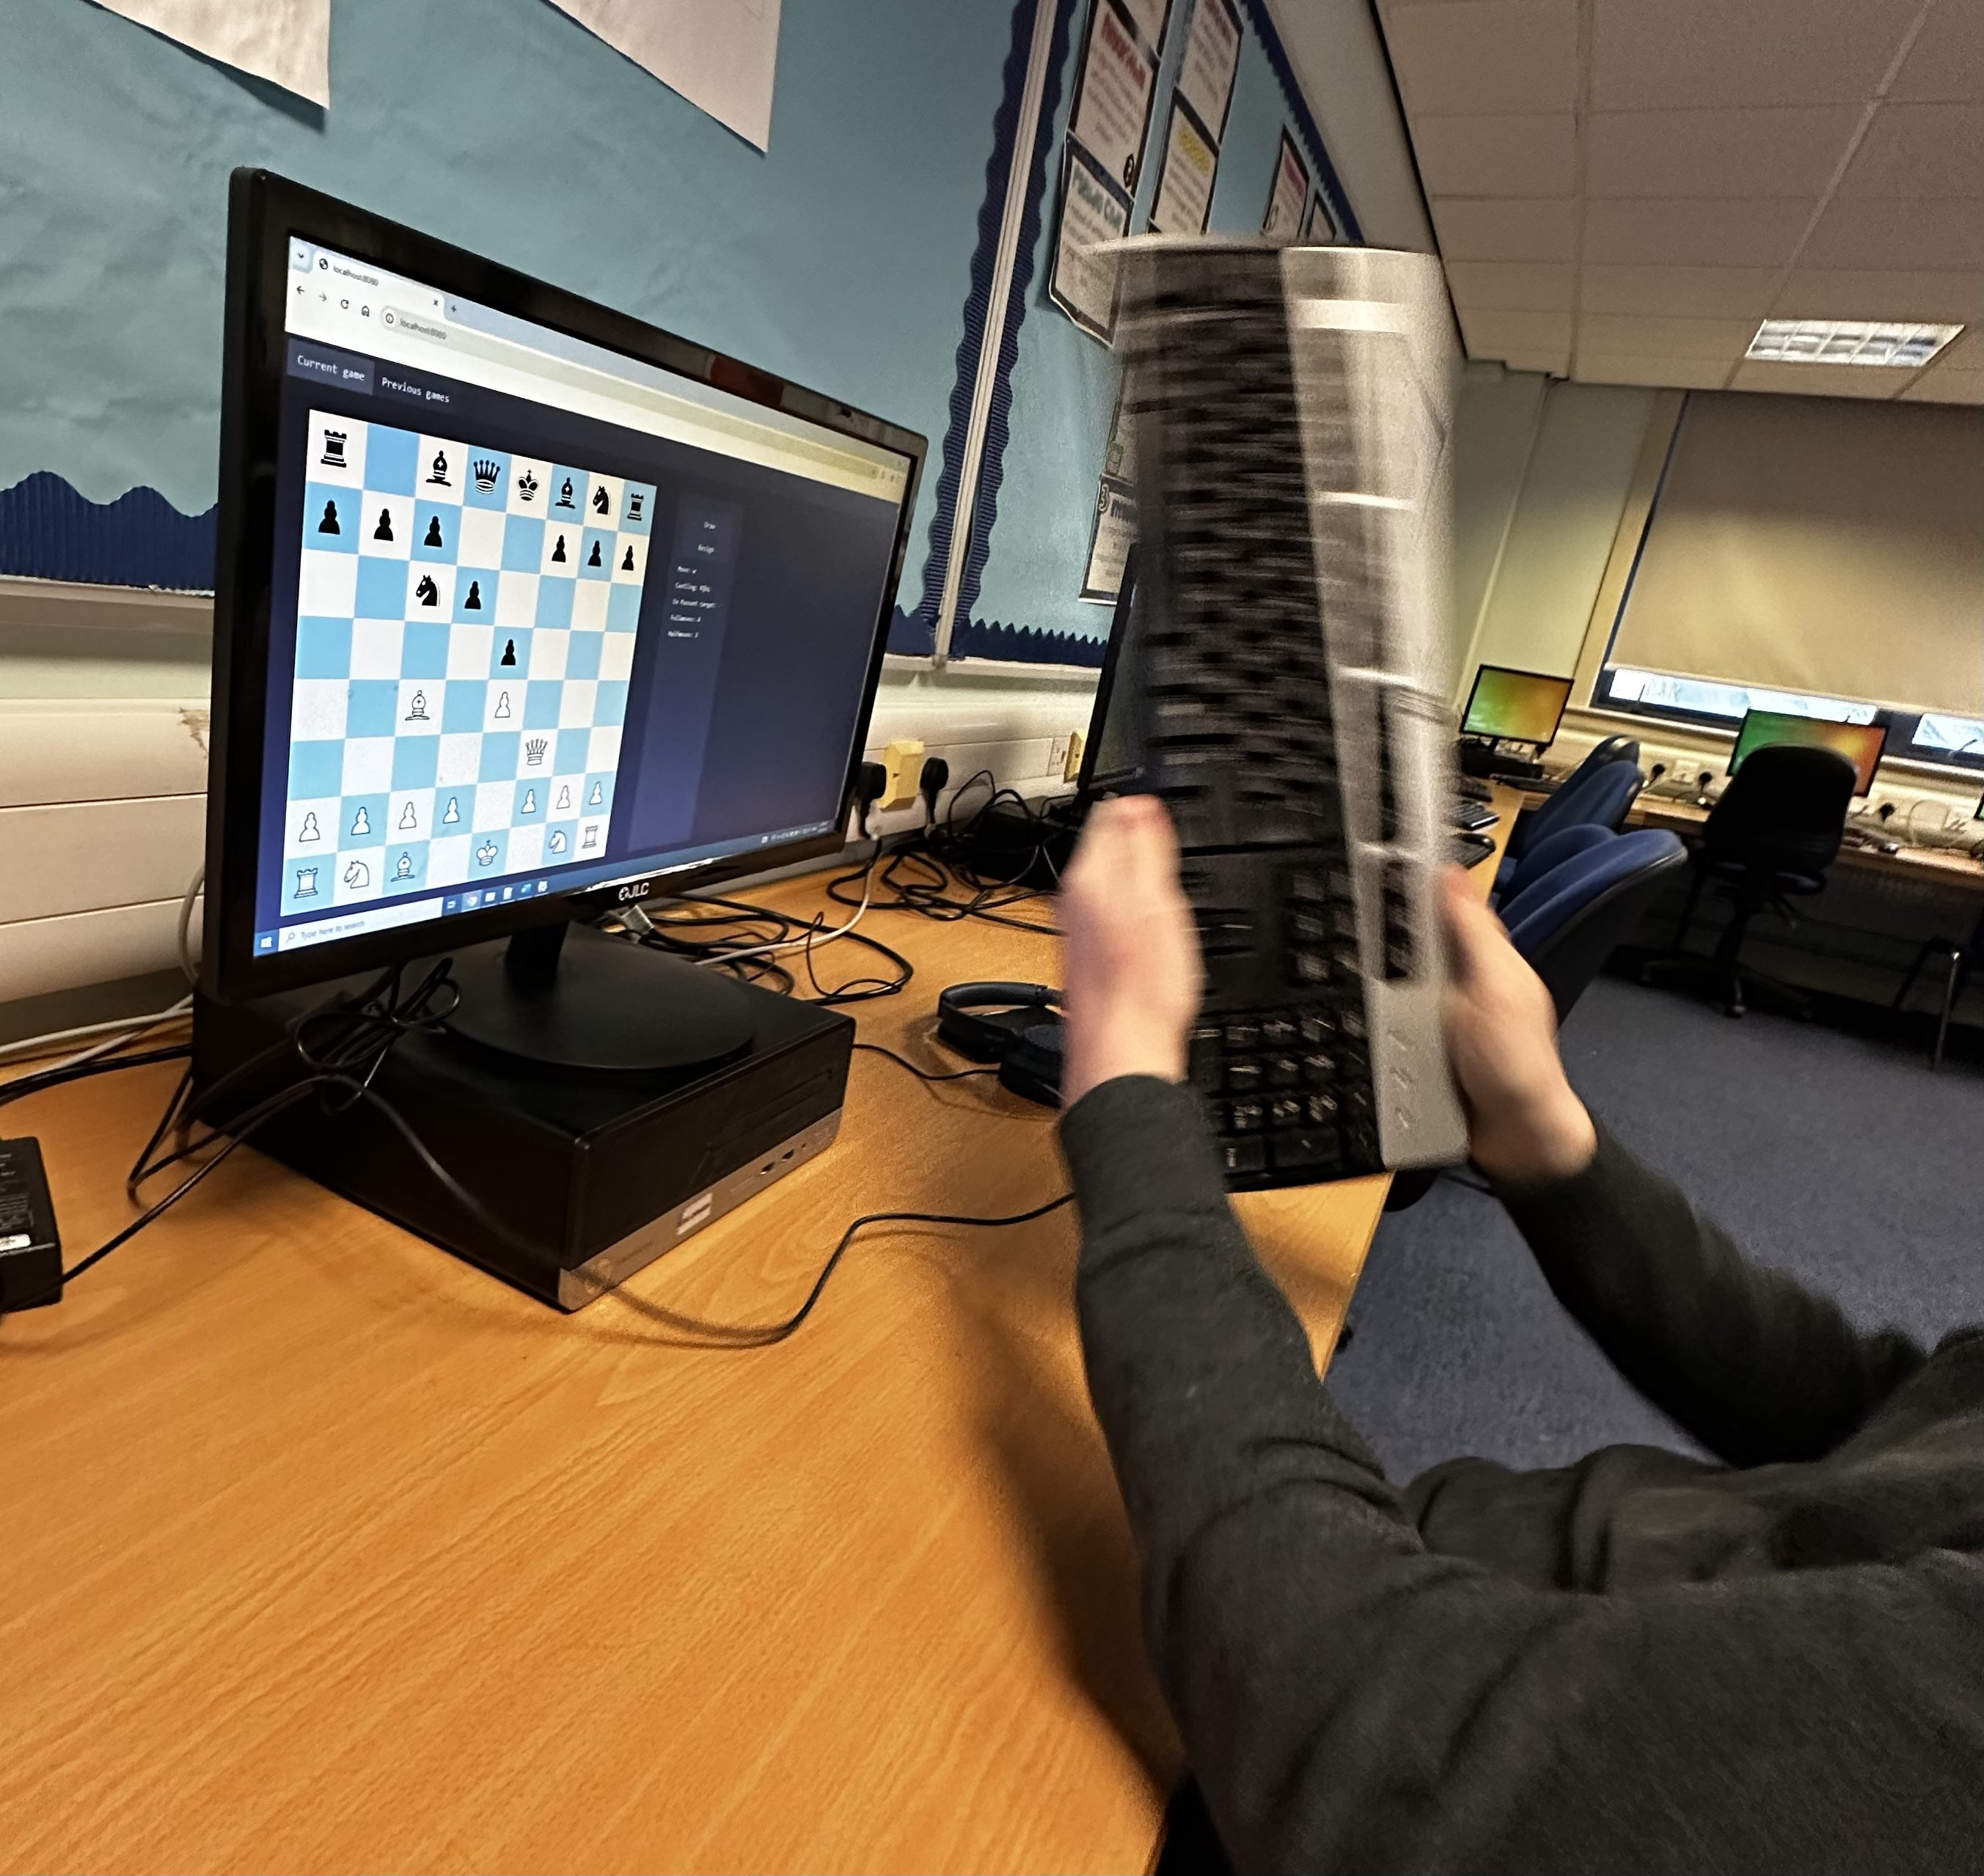

# Contents

Analysis 5  
UML Use case diagram 7  
Requirements spec 9  
Plan 11  
  
Main program design 13  
UI/Integration design 43  
  
Implementation 51  
Research 109  
Log of testing 111  
  
Testing 115  
Testing evidence 119  
Persona testing 151  
Evaluation 153

# Analysis of the problem

## Description of the problem

An **object orientated program** with an **array of objects** is required to create the game of chess, which will be played on a web browser.

The program will utilize multiple arrays of objects. Each separate game will be stored as an object, and will be stored on the file system after the game is completed. Inside this object, each position of the game will also be stored as an object, with all the positions being another array of objects. Separate games will be stored in an object which will contain methods to save and load games in JSON format, which will contain an array of FENs. With individual positions, each position will be stored in an object using the same attributes as FEN format. A FEN is simply a format for storing the specific position of a chess game, including the board, whose move it is, et cetera.

The user will be able to browse previous games, and a **bubble sort algorithm** will be implemented to sort games by most recent, in order to aid the user in finding a specific game that they have played in the past. However, only bubble sort will be used for this.

During a game, the players will input their desired moves using the user interface, which will be a chess board in the browser. When a player makes a move, it will be **validated** to ensure that it is that player’s turn, and that the move is legal. The program will keep track of whose move it is, and move will be validated to ensure they are legal. Once a move is made, it will switch to the other player’s turn, and if it is checkmate or stalemate the game will end. Both players will be using the same computer, and will just take turns at using the user interface to make their moves.

The entire user interface will be web-based, and this will be the only way the web integration will be used – all the chess logic, input validation et cetera will be written in Python. There will be an http server written in Python which will serve the web pages to the user, alongside the minimal amount of JavaScript required to make this integration work. For the user interface, a chess board will be displayed on the web page and the user will be able to select a square, then click on another square to make a move. This move will be sent to the python side of the program to be validated, and if it is valid, sorted and returned to the web part of the program to be displayed to the user. There will be a separate page to display previous games, which will display games to the user. Games will be sorted by most recent, and the user will be able to select a game, and view each move of the game. Information about the user’s request and the game will be sent back and forth between the python part of the program, and the web part.

The program will not have a timer which would allow for timed games (ie player loses if they run out of time), or any way for players to play a game when they are on different computers. The program will also only provide standard chess (no variations such as Chess960)

Overall, the purpose of the program is to be an object orientated program utilizing an array of objects and bubble sort, that will allow the user to be able to play a game of chess against another player using the same computer. The user will be able to access previous games using the user interface, and will be able to view details about a specific game. Each game will be stored in a .json file, which will be stored in the file system on the player’s computer.

## Resources Required

## Browser capable of displaying HTML from localhost:8080

* A computer capable of running Python
* People to test the program

## UML use case diagram

## Requirements specification

End-user requirements:

Users are required to be able to:

* The user should be able to play a game of chess against themselves or another person using the same computer
* The user should be able to see previous games using the user interface, which should be sorted by most recently played. The user should then be able to see each move of that game
* Make chess moves in an intuitive way by clicking on the square with the piece they wish to move, then they click on the square they want to move the piece to.
* Only make legal moves, so all moves will be validated.

Functional requirements:

* The main page (where the players play the game) should have:
  + The game board
  + Buttons to draw or resign the game
  + A link to the previous games page
* The previous games page should have:
  + A list of all previous games, sorted by most recent being first
  + Each previous game should link to a page containing data for that game
  + A link to the main page
* The previous game page should have:
  + The game board (the user will not be able to make moves)
  + Two buttons to go forward a move and backwards a move
  + A panel at the side containing information about the game, such as who won
* The HTTP server should:
  + Serve the webpages that are the user interface
  + Have endpoints for getting data about previous games
  + Have endpoints for getting data of the current game
  + Have an endpoint for playing a move in the current game

Input validation

* In-game, all moves should be validated to ensure that they are legal. This means that a player should only be able to move their own pieces, and should only be able to play when it is their turn. Additionally, special moves such as castling and en passent need to be recognised as legal moves so that the players can play them, but only when they are allowed to.
* The validation will ensure that illegal moves cannot be played, and that the board position will not change when an illegal move is played
* The validation will ensure that the game will end on checkmate or stalemate, so moves cannot be played after the game ends

## 

## Project plan

|  |  |  |  |  |  |  |  |  |  |
| --- | --- | --- | --- | --- | --- | --- | --- | --- | --- |
| WB: | 02/11/2023 | 09/11/2023 | 16/11/2023 | 23/11/2023 | 30/11/2023 | 07/12/2023 | 14/12/2023 | 21/12/2023 | 28/12/2023 |
| Analysis |  |  |  |  |  |  |  |  |  |
| Design |  |  |  |  |  |  |  |  |  |
| Implementation |  |  |  |  |  |  |  |  |  |
| Testing |  |  |  |  |  |  |  |  |  |
| Evaluation |  |  |  |  |  |  |  |  |  |

|  |  |  |  |  |  |  |  |  |
| --- | --- | --- | --- | --- | --- | --- | --- | --- |
| 04/01/2024 | 11/01/2024 | 18/01/2024 | 25/01/2024 | 01/02/2024 | 08/02/2024 | 15/02/2024 | 22/02/2024 | 29/02/2024 |
|  |  |  |  |  |  |  |  |  |
|  |  |  |  |  |  |  |  |  |
|  |  |  |  |  |  |  |  |  |
|  |  |  |  |  |  |  |  |  |
|  |  |  |  |  |  |  |  |  |

This plan estimated approximately 1 hour of work a day, or about 10 hours per week

Design:

* Creating UML class diagrams - ~ 5 days
* Designing the user interface - ~ 3 days
* Designing HTTP endpoints for HTTP server - ~ 3 days
* Writing flowcharts - ~ 14 days

Implementation (all times include continuous testing):

* Implementing HTTP server for serving webpages - ~ 1 days
* Implementing HTTP endpoint for backend communication - ~ 1 days once HTTP server for webpage is complete
* Creating webpages - ~ 7 days
* Implementing classes and such - ~ 7 days
* Implementing move validation - ~ 14 days
* Implementing sorting algorithm - ~ 2 days

Testing:

* Creating test plan – ~ 5 days
* Test move/input validation - ~ 2 days
* Test user interface - ~ 3 days
* Test viewing previous games - ~ 3 days
* Test game saving - ~ 3 days

Evaluation:

* Creating evaluation report - ~ 7 days

# Design of the solution

## Project Design

Note

Single lines of code that are split into multiple lines are underlined. The lines are also indented to seperate them from the other code as shown  
AH concepts are highlighted in yellow  
v0 version of pseudocode is unhighlighted  
v1 version is highlighted in blue, unless it is an AH concept, then it is in green

For all UML class diagrams, the latest version is used

### Design of Main Program

### main.py

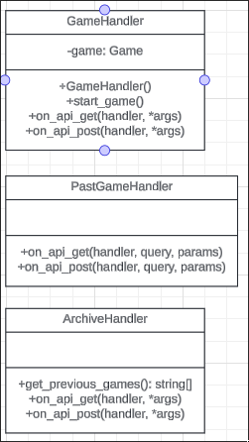

class GameHandler

constructor()

start_game()

fn start_game()

set starting_date to current date

set starting_time to current time

set starting_fen to fen for default position

set this.game to a new instance of Game

fn on_api_get(handler, *args)

send 200 response

send headers

set response to current position in JSON format

write response to wfile

fn on_api_post(handler, *args)

set request to rfile in JSON format

add move to game, using data from request JSON

if game has ended

save game to file with name containing starting date and time

start_game()

send 200 response

send headers

class PastGameHandler

fn on_api_get(handler, query, params)

if query is empty

send 400 response

send 200 response

send headers

get game_id from query

get path of game file from game_id

get game in JSON format from reading file with path

for each position in game

get position json of position

edit JSON format of game, replacing fen with position JSON

write game JSON to wfile

fn on_api_post(handler, query, params)

do nothing

class ArchiveHandler

Array of objects

fn get_previous_games()

set games to empty array

for each file in ../games

set game_id to file name

set game to instance of game using path

append game to games

Bubble sort

set n to length of game_ids

set swapped to true

while swapped is true and n >= 0

swapped = false

for i from 0 to n-1

if games[i] datetime as number is bigger than games[i+1] datetime as number

swap games[i] and games[i+1]

swapped = true

n -= 1

fn on_api_get(handler, *args)

send 200 response

send headers

set games to get_previous_games()

write ids of games as JSON to wfile

main program

set server to instance of WebServer, with port 8080, and RequestHandler as http request handler

add resource handlers for all .svg .css and .js

add api handlers for /api/board /api/game /api/games

add webpage handlers for / /game /games

serve server forever until keyboard interrupt, then close server

### server.py

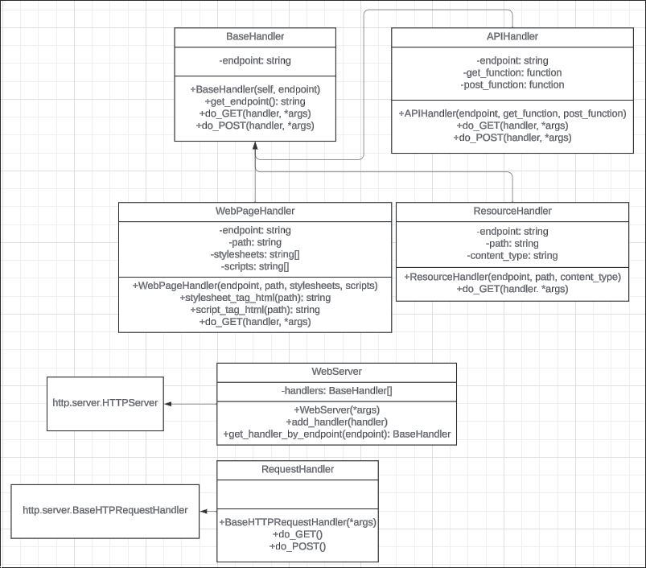

class BaseHandler

constructor(endpoint)

set endpoint

fn get_endpoint

return endpoint

fn do_GET(handler, *args)

do nothing

fn do_POST(handler, *args)

do nothing

class WebPageHandler extends BaseHandler

constructor(endpoint, path, stylesheets, scripts)

set path, stylesheets, endpoints, scripts

private fn stylesheet_tag_html(path)

return stylesheet html tag

private fn script_tag_html(path)

return script html tag

fn do_GET(handler, *args)

send 200 response

send headers

for each path in this.stylesheets

write stylesheet html to wfile

for each path in this.scripts

write script html to wfile

open this.path as readfile

write contents to wfile

class RescourceHandler extends BaseHandler

constructor(endpoint, path, content_type)

set endpoint, path, content_type

fn do_GET(handler, *args)

send 200 response

send headers

send contents of file at path to wfile

class APIHandler extends BaseHandler

constructor(endpoint, get_function, post_funtion)

set endpoint, get_function, post_function

fn do_GET(handler, *args)

call get_function with handler, *args

fn do_POST(handler, *args)

call post_function with handler, *args

class WebServer extends HTTPServer

constructor(*args)

set handlers to empty array

call super class with *args

fn add_handler(handler)

add handler to handlers

fn get_handler_by_endpoint(endpoint)

for each handler in handlers

if endpoint of handler is endpoint

return handler

return basehandler with "" as endpoint

class RequestHandler extends BaseHTTPRequestHandler

fn do_GET()

get path, query, params from super class

get handler with endpoint of path

if handler exists then call do_GET of handler with query, params

else respond with 404

fn do_POST()

get path, query, params from super class

get handler with endpoint of path

if handler exists then call do_POST of handler with query, params

else respond with 404

### chess.py

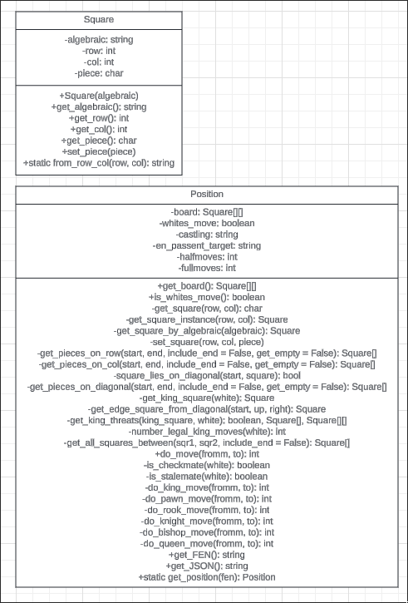

### 

class Square

constructor(algebraic)

set algebraic

set row to (second char of algebraic) - 1

set col to (first char of algebraic to int) - 97

set piece to ""

fn get_algebraic()

return algebraic

fn get_row()

return row

fn get_col()

return col

fn get_piece()

return piece

fn set_piece(piece)

set piece

static fn from_row_col(row, col)

return (col + 97) to ascii char + (row + 1) as string

class Position

constructor(board, whites_move, castling, en_passent_target, halfmoves, fullmoves)

set board, whites_move, castling, en_passent_target, halfmoves, fullmoves

fn get_board()

return board

fn is_whites_move()

return whites_move

private fn get_square(row, col)

return board[7 - row][col].get_piece()

private fn get_square_instance(row, col)

return board[7 - row][col]

private fn get_square_by_algebraic(algebraic)

set row to second char to int + 1

set col to first char to int - 97

return board[7 - row][col]

private fn set_square(row, col, piece)

board[7 - row][col].set_piece(piece)

private fn get_pieces_on_row(start, end, include_end = false, get_empty = false)

set pieces to empty array

set row to start square's row

if row and end row are not the same

stop program

step = 1 if start col < end col else -1

col = start col + step

end_col = end col

while col does not equal end_col + (step if include_end)

piece = get_square_instance(row, col)

if get_empty

append piece to pieces

else if piece.get_piece() is not ""

append piece to pieces

col += step

return pieces

private fn get_pieces_on_col(start, end, include_end = false, get_empty = false)

set pieces to empty array

set col to start square's col

if col and end col are not the same

stop program

step = 1 if start row < end row else -1

row = start row + step

end_row = end row

while row not equals end_row + (step if include_end)

piece = get_square_instance(row, col)

if get_empty

append piece to pieces

else if piece.get_piece() not ""

append piece to pieces

row += step

return pieces

private fn square_lies_on_diagonal(start, square)

if |square row - start row| not equals |square col - start col|

return false

return true

private fn get_pieces_on_diagonal(start, end, include_end = false, get_empty = false)

set pieces to empty array

if |start row - end row| not equals |start col - end col|

stop program

up_step = 1 if start row < end row else -1

right_step = 1 if start col < end col else -1

row = start row + up_step

col = start col + right_step

while row not equals end row + (up_step if include_end) and col not equals end col +

(right_step if include_end)

piece = get_square_instance(row, col)

if get_empty:

append piece to pieces

else if piece.get_piece() not equals ""

append piece to pieces

row += up_step

col += right_step

return pieces

private fn get_king_square(white)

for each row in board

for each col in row

if piece is king

return square

raise exception

private fn get_edge_square_from_diagonal(start, up, right)

up_step = 1 if up else -1

right_step = 1 if right else -1

up_limit = 7 if up else 0

right_limit = 7 if right else 0

row = start row

col = start col

while row not equals up_limit and col not equals right_limit

row += up_step

col += right_step

return square instance at row, col

private fn get_king_threats(king_square)

set straights to empty array

append each straight going from king square to edge of board to straights

set diagonals to empty array

append each diagonal going from king square to edge of board to diagonals

set checking pieces to empty array

set pinned pieces to empty array

for each line in straights

set to_check_index to 0

set piece to line[to_check_index]

if length of line is 0

do nothing (dont do code after this in loop)

if first piece in line is king

to_check_index = 1

if length of line is 1

do nothing

if piece is own piece

if piece after to_check_index is enemy queen or rook

append line[to_check_index + 1], piece] to pinned pieces

else if piece is enemy queen or rook

append piece to checking_pieces

for each line in diagonals

set to_check_index to 0

set piece to line[to_check_index]

if length of line is 0

do nothing (dont do code after this in loop)

if first piece in line is king

to_check_index = 1

if length of line is 1

do nothing

if piece is own piece

if piece after to_check_index is enemy queen or bishop

append line[to_check_index + 1], piece] to pinned pieces

else if piece is enemy queen or bishop

append piece to checking_pieces

set in_check to false

if length of checking_pieces not equals 0

in_check = true

// For pawn

if there is enemy pawn in front and 1 square to right or left of king_square

append pawn square to checking pieces

in_check = true

// For knight

if square 2 away in one dir and 1 away in other from king square is enemy knight

append knight square to checking pieces

in_check = true

// For king

if |enemy king row - king row| <= 1 and |enemy king col - king col| <= 1

append enemy king square to checking pieces

in_check = true

return in_check, checking_pieces, pinned_pieces

private fn number_legal_king_moves(white)

legal_squares = 0

for i from -1 to 1

for j from -1 to 1

if i and j are not both 0

row = king row + i

col = king col + j

if row and col are between 0 and 7 inclusive

if square would not be in check if it had a king and

does not have own piece

legal_squares += 1

return legal_squares

private fn get_all_squares_between(sqr1, sqr2, include_end = false)

if sqr1 and sqr2 on same row

return get_pieces_on_row(sqr1, sqr2, include_end, true)

else if sqr1 and sqr2 on same col

return get_pieces_on_col(sqr1, sqr2, include_end, true)

else if sqr1 and sqr2 on same diagonal

return get_pieces_on_diagonal(sqr1, sqr2, include_end, true)

else

throw exception

fn do_move(fromm, to)

if not players turn

return -1

if fromm equals to

return -1

if capturing own piece

return -1

if king is in check

if number of checking pieces > 1

if piece is not king

return -1

for each pinned piece

if moving pinned piece

if piece is not moving in same direction as pinning piece

return -1

switch piece

case king

result = do_king_move(fromm, to)

case pawn

result = do_pawn_move(fromm, to)

case rook

result = do_rook_move(fromm, to)

case knight

result = do_knight_move(fromm, to)

case bishop

result = do_bishop_move(fromm, to)

case queen

result = do_queen_move(fromm, to)

if checkmate

return 3

if stalemate

return 2

return result

return -1

private fn is_checkmate(white)

if not in check

return false

if number checking pieces > 1

if number legal king moves equals 0

return true

else

if king is only piece

return true

if number legal king moves equals 0

if checking piece can be captured

return false

else

for each square inbetween checking piece and king

if own piece can move there

return false

return true

private fn is_stalemate(white)

if king is only own piece left

if king can move

return false

else

return true

for each own piece

if piece is pinned to king

if piece can capture pinning piece

return false

if piece is pawn

if able to move forward

return false

if able to capture

return false

return true

private fn do_king_move(fromm, to)

if moving on inital row and moving more than 1 space

if moving to right // kingside

if cannot castle kingside

return -1

else // queenside

if cannot castle queenside

return -1

if pieces between king and rook

return -1

if king is in check or squares between king and rook would be in check

return -1

move rook to col 5 if kingside else 3

move king ro col 6 if kingside else 2

update castling

switch turns

update fullmove counter

set en_passent target to "-"

update halfmove counter

if halfmoves equals 50

return 1

return 0

if moving more than 1 space

return -1

if moving to space that would be in check

return -1

move king to square

update castling

switch turns

update fullmove and halfmove counter

if halfmoves equals 50

return 1

set en passent target to "-"

return 0

private fn do_pawn_move(fromm, to)

if capturing

if not 1 square behind square that is being moved to

return -1

if not 1 away left or right

return -1

if capturing en passent

remove captured pawn

else

if not moving on same col

return -1

if on starting square

if moving more than 2 spaces forward

return -1

if moving 2 spaces forward

set en passent target

else

if moving more than 1 space forward

return -1

if king would be in check

return -1

set en passent target to "-" if no target set in move

move pawn

if at end of board

promote to queen

switch turns

update fullmoves

set halfmoves to 0

return 0

private fn do_rook_move(fromm, to)

if fromm and to are not on same row/col

return -1

if pieces between rook square and square moving to

return -1

if king would be check

return -1

update castling legality

move rook

switch turns

update halfmove and fullmove counter

if halfmoves equals 50

return 1

set en passent target to "-"

return 0

private fn do_knight_move(fromm, to)

if 2 rows away

if not 1 col away

return -1

else if 1 row away

if not 2 cols away

return -1

else

return -1

if king would be in check

return -1

move knight

switch turns

update fullmove and halfmove counter

if halfmoves equals 50

return 1

set en passent target to "-"

return 0

private fn do_bishop_move(fromm, to)

if not moving on diagonal

return -1

if there are pieces between fromm and to squares

return -1

if king would be in check

return -1

move bishop

switch turns

update fullmove and halfmove counter

if halfmoves equals 50

return 1

set en passent target to "-"

return 0

private fn do_queen_move(fromm, to)

if not travelling on same row/col/diagonal

return -1

if pieces between fromm and to square

return -1

if king would be in check

return -1

move queen

switch turns

update fullmove and halfmove counter

if halfmoves equals 50

return 1

set en passent target to "-"

return 0

fn get_FEN()

return {

"board": board,

"whitesMove": whites_move,

"castling": castling,

"enPassentTarget": en_passent_target,

"halfmoves": halfmoves,

"fullmoves": fullmoves

} as string

static fn get_position(fen)

parts = split fen by " "

rows = split parts[0] by "/"

board = 8*8 2d array

for each row in board

for each col in board

board[7 - row][col] = instance of Square

for each row in rows

set index to 0

set relative_index to 0

while index < length row

if current char is number

add to relative index

else

board[i]

[relative_index]

.set_piece(current char)

relative_index += 1

index += 1

whites_move = parts[1] == "w"

castling = parts[2]

en_passent_target = parts[3]

halfmoves = parts[4]

fullmoves = parts[5]

return Position(board, whites_move, castling, en_passent_target, halfmoves, fullmoves)

class Game

constructor(starting_date, starting_time, starting_fen, result = "*", positions = [])

set date, time, fen, result, positions

set current_pos to Position.get_position(starting_fen)

set fullmove to 1

fn get_starting_date()

return starting_date

fn get_starting_time()

return starting_time

fn ended()

return true if result not equals "*" else false

fn get_current_pos()

return current_pos

fn add_move(fromm, to, result_int = 0)

if ended()

throw exception

if result_int equals 0

set result_int to current_pos.do_move(fromm, to)

if result_int not equals -1

append current pos as fen to positions

if result_int equals 1

result = "1-0" if whites move else "0-1"

else if result_int equals 2

result = "1/2-1/2"

else if result_int equals 3

result = "0-1" if whites move else "1-0"

fn get_JSON()

return {

"date": this.date,

"time": this.time,

"fen": this.fen,

"result": this.result,

"positions": this.positions

} as string

fn write_to_file(path)

create file at path

write this.get_JSON() result to file

close writer

static fn read_from_file(path)

open file at path to read

parse file contents to json

return Game instance with stuff from json

### Design of integration

- 3 pages - / (main page), /game (previous game page), /games (previous games page)

### Pseudocode for getting input/displaying output

### 

when square is clicked on main page board

if board does not accept input

do nothing

if clicked square is unoccupied and there is no previously clicked square

do nothing

if no previously clicked square

set previously clicked square to clicked square

do nothing

requestData = json with algebraic notation of prev clicked square, and currently clicked square

do POST to /api/board

send application/json header

send requestData

update board with response

update info box

when resign/draw button is clicked on main page

requestData = json with from set to -, to set to -, and result as 1 if resign, 2 if draw

do POST to /api/board

send application/json header

send requestData

update board with response (this will be a new game)

update info box

for /game

gameId = after "id=" in url

(should be /game?id=something)

do GET from /api/gmae?id={gameId}

send headers

parse response to json

update board with response, and game position 1

set box info

on < or > button pressed

increment or decrement position

update board

update info box

for /games

do GET from /api/games

parse response to json

for each game in response

display box for game

## User-Interface design

SVGs for the chess pieces from <https://commons.wikimedia.org/wiki/Category:SVG_chess_pieces> will be used

## A screenshot of a computer Description automatically generatedMain page

## A screenshot of a computer Description automatically generatedPrevious game page

## Previous games page

# Implementation

## Implementation

## Note:

Due to the page width, some lines of code are split into 2. This is very obvious when in occurs, and is easy to spot.

Svgs from <https://commons.wikimedia.org/wiki/Category:SVG_chess_pieces> are used for the chess pieces. These are not included here

If a file is a .py, then it is part of the main program. Otherwise it is part of the implementation.

## main.py

**from** http.server **import** BaseHTTPRequestHandler, HTTPServer

**from** os **import** listdir

**from** urllib.parse **import** urlparse

**class** BaseHandler():

**def** __init__(self, endpoint):

self._endpoint = endpoint

**def** get_endpoint(self):

**return** self._endpoint

**def** do_GET(self, handler, *args):

**pass**

**def** do_POST(self, handler, *args):

**pass**

**class** WebPageHandler(BaseHandler):

**def** __init__(self, endpoint, path, stylesheets, scripts):

self._path = path

self._stylesheets = stylesheets

self._scripts = scripts

super().__init__(endpoint)

**def** __stylesheet_tag_html(self, path):

**return** f"<link rel='stylesheet' href='{path}'>"

**def** __script_tag_html(self, path):

**return** f"<script type='text/javascript' src='{path}'></script>"

**def** do_GET(self, handler, *args):

handler.send_response(200)

handler.send_header("Content-type", "text/html")

handler.end_headers()

**for** path **in** self._stylesheets:

handler.wfile.write(bytes(self.__stylesheet_tag_html(path), "utf-8"))

**for** path **in** self._scripts:

handler.wfile.write(bytes(self.__script_tag_html(path), "utf-8"))

**with** open(self._path, "rb") **as** file:

handler.wfile.write(file.read())

**class** ResourceHandler(BaseHandler):

**def** __init__(self, endpoint, path, content_type):

self._path = path

self._content_type = content_type

super().__init__(endpoint)

**def** do_GET(self, handler, *args):

handler.send_response(200)

handler.send_header("Content-type", self._content_type)

handler.end_headers()

**with** open(self._path, "rb") **as** file:

handler.wfile.write(file.read())

**class** APIHandler(BaseHandler):

**def** __init__(self, endpoint, get_function, post_function):

self._get_function = get_function

self._post_function = post_function

super().__init__(endpoint)

**def** do_GET(self, handler, *args):

self._get_function(handler, *args)

**def** do_POST(self, handler, *args):

self._post_function(handler, *args)

**class** WebServer(HTTPServer):

**def** __init__(self, *args):

self._handlers = []

super().__init__(*args)

**def** add_handler(self, handler):

self._handlers.append(handler)

**def** get_handler_by_endpoint(self, endpoint):

**for** handler **in** self._handlers:

**if** handler.get_endpoint() == endpoint:

**return** handler

**return** BaseHandler("")

**class** RequestHandler(BaseHTTPRequestHandler):

**def** do_GET(self):

parsed = urlparse(self.path)

path = parsed.path

query = parsed.query

params = parsed.params

handler = self.server.get_handler_by_endpoint(path)

**if** handler.get_endpoint() == "":

self.send_response(404)

**else**:

handler.do_GET(self, query, params)

**def** do_POST(self):

parsed = urlparse(self.path)

path = parsed.path

query = parsed.query

params = parsed.params

handler = self.server.get_handler_by_endpoint(path)

**if** handler.get_endpoint() == "":

self.send_response(404)

**else**:

handler.do_POST(self)

## main.py

**from** server **import** *

**import** json

**from** chess **import** *

**from** datetime **import** datetime

**import** os

**class** GameHandler():

**def** __init__(self):

self.start_game()

**def** start_game(self):

# Save game

starting_date = datetime.today().strftime("%Y-%m-%d")

starting_time = datetime.today().strftime("%H-%M-%S")

starting_fen = "rnbqkbnr/pppppppp/8/8/8/8/PPPPPPPP/RNBQKBNR w KQkq - 0 1"

self._game = Game(starting_date, starting_time, starting_fen, "*", [])

# send data to update board and info box

**def** on_api_get(self, handler, *args):

handler.send_response(200)

handler.send_header("Content-type", "application/json")

handler.end_headers()

response = self._game.get_current_pos().get_JSON()

handler.wfile.write(bytes(response, "utf-8"))

# on move made by player

**def** on_api_post(self, handler, *args):

request = json.loads(handler.rfile.read1().decode("utf-8"))

self._game.add_move(request['from'], request['to'], int(request['result']))

**if** self._game.ended():

# Write game to file

date_and_time = self._game.get_date_time() + ".json"

dirname = os.path.dirname(__file__)

filename = date_and_time

path = os.path.join(dirname, '../games/' + filename)

self._game.write_to_file(path)

self.start_game()

handler.send_response(200)

handler.send_header("Content-type", "application/json")

handler.end_headers()

**class** PastGameHandler():

**def** on_api_get(self, handler, query, params):

**if** query == "":

handler.send_response(400)

handler.end_headers()

handler.send_response(200)

handler.send_header("Content-type", "application/json")

handler.end_headers()

game_id = query.split("=")[1] + ".json"

dirname = os.path.dirname(__file__)

path = os.path.join(dirname, '../games/' + game_id)

game = json.loads(Game.read_from_file(path).get_JSON())

**for** i **in** range(len(game['positions'])):

fen = game['positions'][i]

pos = Position.get_position(fen)

game['positions'][i] = json.loads(pos.get_JSON())["board"]

handler.wfile.write(bytes(json.dumps(game), "utf-8"))

**def** on_api_post(self, handler, query, params):

**pass**

**class** ArchiveHandler():

# returns a reverse chronologically sorted list of previous games

# %Y-%m-%d-%H-%M-%S

**def** get_previous_games(self):

games = []

**for** file **in** listdir("../games/"):

game_id = file.split(".")[0]

game = Game.read_from_file("../games/" + game_id + ".json")

games.append(game)

# Bubble sort

n = len(games)

swapped = True

**while** swapped **and** n >= 0:

swapped = False

**for** i **in** range(n-1):

**if** games[i].get_date_time().replace("-", "") > games[i+1].get_date_time().replace("-", ""):

temp = games[i]

games[i] = games[i+1]

games[i+1] = temp

swapped = True

n -= 1

**return** games

**def** on_api_get(self, handler, *args):

handler.send_response(200)

handler.send_header("Content-type", "application/json")

handler.end_headers()

games = self.get_previous_games()

game_ids = [x.get_date_time() **for** x **in** games]

response = json.dumps({ "games": (game_ids) })

handler.wfile.write(bytes(response, "utf-8"))

**def** on_api_post(self, handler, *args):

**pass**

**if** __name__ == "__main__":

server = WebServer(("localhost", 8080), RequestHandler)

**print**("Server started")

# Serves all the .svg files in the ./svgs/ directory

# Only chess piece svgs should be in this dir

**for** file **in** listdir("./svgs/"):

server.add_handler(ResourceHandler(f"/{file}", f"./svgs/{file}", "image/svg+xml"))

server.add_handler(ResourceHandler("/board.css", "./styles/board.css", "text/css"))

server.add_handler(ResourceHandler("/info.css", "./styles/info.css", "text/css"))

server.add_handler(ResourceHandler("/main-page.css", "./styles/main-page.css", "text/css"))

server.add_handler(ResourceHandler("/game-page.css", "./styles/game-page.css", "text/css"))

server.add_handler(ResourceHandler("/games-page.css", "./styles/games-page.css", "text/css"))

server.add_handler(ResourceHandler("/navbar.css", "./styles/navbar.css", "text/css"))

server.add_handler(ResourceHandler("/buttons.css", "./styles/buttons.css", "text/css"))

server.add_handler(ResourceHandler("/games.css", "./styles/games.css", "text/css"))

server.add_handler(ResourceHandler("/global.css", "./styles/global.css", "text/css"))

server.add_handler(ResourceHandler("/board.js", "./scripts/board.js", "text/javascript"))

server.add_handler(ResourceHandler("/main-page.js", "./scripts/main-page.js", "text/javascript"))

server.add_handler(ResourceHandler("/info.js", "./scripts/info.js", "text/javascript"))

server.add_handler(ResourceHandler("/game-page.js", "./scripts/game-page.js", "text/javascript"))

server.add_handler(ResourceHandler("/games-page.js", "./scripts/games-page.js", "text/javascript"))

server.add_handler(ResourceHandler("/buttons.js", "./scripts/buttons.js", "text/javascript"))

server.add_handler(ResourceHandler("/games.js", "./scripts/games.js", "text/javascript"))

game_handler = GameHandler()

server.add_handler(APIHandler("/api/board", game_handler.on_api_get, game_handler.on_api_post))

past_game_handler = PastGameHandler()

server.add_handler(APIHandler("/api/game", past_game_handler.on_api_get, past_game_handler.on_api_post))

archive_handler = ArchiveHandler()

server.add_handler(APIHandler("/api/games", archive_handler.on_api_get, archive_handler.on_api_post))

server.add_handler(WebPageHandler("/", "./pages/main-page.html",

["/global.css", "/board.css", "/info.css",

"/main-page.css", "/navbar.css", "/buttons.css"],

["/board.js", "/info.js", "/main-page.js",

"/buttons.js"]))

server.add_handler(WebPageHandler("/game", "./pages/game-page.html",

["/board.css", "/info.css", "/game-page.css",

"/navbar.css", "/buttons.css", "/global.css"],

["/board.js", "/info.js", "/game-page.js",

"/buttons.js"]))

server.add_handler(WebPageHandler("/games", "./pages/games-page.html",

["/navbar.css", "/games-page.css", "/games.css",

"/global.css"],

["/games-page.js", "/games.js"]))

**try**:

server.serve_forever()

**except** KeyboardInterrupt:

**pass**

server.server_close()

## chess.py

**import** json

**class** Square():

**def** __init__(self, algebraic):

self._algebraic = algebraic

self._row = int(algebraic[1]) - 1

self._col = ord(algebraic[0]) - 97

self._piece = ""

**def** get_algebraic(self):

**return** self._algebraic

**def** get_row(self):

**return** self._row

**def** get_col(self):

**return** self._col

**def** get_piece(self):

**return** self._piece

**def** set_piece(self, piece):

self._piece = piece

@staticmethod

**def** from_row_col(row, col):

**return** chr(97 + col) + str(row + 1)

**class** Position():

**def** __init__(self, board, whites_move, castling, en_passent_target, halfmoves, fullmoves):

self._board = board

self._whites_move = whites_move

self._castling = castling

self._en_passent_target = en_passent_target

self._halfmoves = halfmoves

self._fullmoves = fullmoves

**def** get_board(self):

**return** self._board

**def** is_whites_move(self):

**return** self._whites_move

# row and col as would be in algebraic notation except not

**def** __get_square(self, row, col):

**return** self._board[7 - row][col].get_piece()

**def** __get_square_instance(self, row, col):

**return** self._board[7 - row][col]

**def** __get_square_by_algebraic(self, algebraic):

row = int(algebraic[1]) - 1

col = ord(algebraic[0]) - 97

**return** self._board[7 - row][col]

**def** __set_square(self, row, col, piece):

self._board[7 - row][col].set_piece(piece)

# start and end are squares

**def** __get_pieces_on_row(self, start, end, include_end = False, get_empty = False):

pieces = []

row = start.get_row()

**if** row != end.get_row():

**raise** Exception("Not on same row")

step = 1 **if** start.get_col() < end.get_col() **else** -1

col = start.get_col() + step

end_col = end.get_col()

**while** col != end_col + (step **if** include_end **else** 0):

piece = self.__get_square_instance(row, col)

**if** get_empty:

pieces.append(piece)

**elif** piece.get_piece() != "":

pieces.append(piece)

col += step

**return** pieces

**def** __get_pieces_on_col(self, start, end, include_end = False, get_empty = False):

pieces = []

col = start.get_col()

**if** col != end.get_col():

**raise** Exception("Not on same col")

step = 1 **if** start.get_row() < end.get_row() **else** -1

row = start.get_row() + step

end_row = end.get_row()

**while** row != end_row + (step **if** include_end **else** 0):

piece = self.__get_square_instance(row, col)

**if** get_empty:

pieces.append(piece)

**elif** piece.get_piece() != "":

pieces.append(piece)

row += step

**return** pieces

**def** __square_lies_on_diagonal(self, start, square):

start_row = start.get_row()

start_col = start.get_col()

normalized_square_row = square.get_row() - start_row

normalized_square_col = square.get_col() - start_col

**if** abs(normalized_square_row) != abs(normalized_square_col):

**return** False

**return** True

**def** __get_pieces_on_diagonal(self, start, end, include_end = False, get_empty = False):

pieces = []

start_row = start.get_row()

start_col = start.get_col()

end_row = end.get_row()

end_col = end.get_col()

**if** abs(start_row - end_row) != abs(start_col - end_col):

**raise** Exception("Not on same diagonal")

up_step = 1 **if** start_row < end_row **else** -1

right_step = 1 **if** start_col < end_col **else** -1

row = start_row + up_step

col = start_col + right_step

**while** row != end_row + (up_step **if** include_end **else** 0) **and** col != end_col + (right_step **if** include_end **else** 0):

piece = self.__get_square_instance(row, col)

**if** get_empty:

pieces.append(piece)

**elif** piece.get_piece() != "":

pieces.append(piece)

row += up_step

col += right_step

**return** pieces

**def** __get_king_square(self, white):

**for** i **in** range(8):

**for** j **in** range(8):

piece = self.__get_square(i, j)

**if** (white **and** piece == "K") **or** (**not** white **and** piece == "k"):

**return** self.__get_square_instance(i, j)

**raise** Exception("No king on board")

**def** __get_edge_square_from_diagonal(self, start, up, right):

up_step = 1 **if** up **else** -1

right_step = 1 **if** right **else** -1

up_limit = 7 **if** up **else** 0

right_limit = 7 **if** right **else** 0

row = start.get_row()

col = start.get_col()

**while** row != up_limit **and** col != right_limit:

row += up_step

col += right_step

**return** self.__get_square_instance(row, col)

# given a king square, it will return an array with forbidden king squares, and pinned pieces

# for a potential move, if checking pieces array has entries then move is illegal

**def** __get_king_threats(self, king_square, white):

straights = []

straights.append(self.__get_pieces_on_col(king_square, self.__get_square_instance(7, king_square.get_col()), True))

straights.append(self.__get_pieces_on_col(king_square, self.__get_square_instance(0, king_square.get_col()), True))

straights.append(self.__get_pieces_on_row(king_square, self.__get_square_instance(king_square.get_row(), 7), True))

straights.append(self.__get_pieces_on_row(king_square, self.__get_square_instance(king_square.get_row(), 0), True))

diagonals = []

diagonals.append(self.__get_pieces_on_diagonal(king_square, self.__get_edge_square_from_diagonal(king_square, True, True), True))

diagonals.append(self.__get_pieces_on_diagonal(king_square, self.__get_edge_square_from_diagonal(king_square, False, True), True))

diagonals.append(self.__get_pieces_on_diagonal(king_square, self.__get_edge_square_from_diagonal(king_square, False, False), True))

diagonals.append(self.__get_pieces_on_diagonal(king_square, self.__get_edge_square_from_diagonal(king_square, True, False), True))

checking_pieces = []

pinned_pieces = [] # 2d array of pinned piece, and attacking piece

**for** line **in** straights:

to_check_index = 0

check_for_pin = False

skip = False

**if** len(line) != 0:

# if first piece in line is own king

**if** line[0].get_piece() == ("K" **if** white **else** "k"):

to_check_index = 1

**if** len(line) == 1:

skip = True

**if** **not** skip:

p = line[to_check_index]

piece = p.get_piece()

enemy_queen = "q" **if** white **else** "Q"

enemy_rook = "r" **if** white **else** "R"

# if to_check_index is own piece, check if piece after is queen or rook

**if** (piece == piece.upper() **and** white) **or** (piece == piece.lower() **and** **not** white):

**if** len(line) > to_check_index + 1:

**if** line[to_check_index + 1].get_piece() == enemy_queen

**or** line[to_check_index + 1].get_piece() == enemy_rook:

pinned_pieces.append([line[to_check_index + 1], p])

**elif** piece == enemy_queen **or** piece == enemy_rook:

checking_pieces.append(p)

**for** line **in** diagonals:

to_check_index = 0

check_for_pin = False

skip = False

**if** len(line) != 0:

# if first piece in line is own king

**if** line[0].get_piece() == ("K" **if** white **else** "k"):

to_check_index = 1

**if** len(line) == 1:

skip = True

**if** **not** skip:

p = line[to_check_index]

piece = p.get_piece()

enemy_queen = "q" **if** white **else** "Q"

enemy_bishop = "b" **if** white **else** "B"

# if to_check_index is own piece, check if piece after is queen or rook

**if** (piece == piece.upper() **and** white) **or** (piece == piece.lower() **and** **not** white):

**if** len(line) > to_check_index + 1:

**if** line[to_check_index + 1].get_piece() == enemy_queen

**or** line[to_check_index + 1].get_piece() == enemy_bishop:

pinned_pieces.append([line[to_check_index + 1], p])

**elif** piece == enemy_queen **or** piece == enemy_bishop:

checking_pieces.append(p)

# By this point all pinned pieces are found

# if straight/diag checking pieces arrays have length, then king must be in check

# return length of both arrays combined - this is the number of axis from which the king is being checked

in_check = False

**if** len(checking_pieces) != 0:

in_check = True

# Check if king is/would be in check from pawn, knight, or king - no pinning here

# for pawn - if pawn is in front of king_square and 1 to left or right then it is checking

pawn_row = king_square.get_row() + (1 **if** white **else** -1)

enemy_pawn = "p" **if** white **else** "P"

**if** king_square.get_col() + 1 < 8 **and** pawn_row >= 0 **and** pawn_row < 8:

**if** self.__get_square(pawn_row, king_square.get_col() + 1) == enemy_pawn:

checking_pieces.append(self.__get_square_instance(pawn_row, king_square.get_col() + 1))

in_check = True

**if** king_square.get_col() - 1 >= 0 **and** pawn_row >= 0 **and** pawn_row < 8:

**if** self.__get_square(pawn_row, king_square.get_col() - 1) == enemy_pawn:

checking_pieces.append(self.__get_square_instance(pawn_row, king_square.get_col() - 1))

in_check = True

# for knight

# if 2 away on row and 1 away on col or 2 away on col and 1 away on row is enemy knight then sqr is forbidden

enemy_knight = "n" **if** white **else** "N"

**for** i **in** range(4):

rel_row = 2

rel_col = 1

**if** i > 1:

rel_row *= -1

**if** i % 2 != 0:

rel_col *= -1

row = king_square.get_row() + rel_row

col = king_square.get_col() + rel_col

**if** row >= 0 **and** row < 8 **and** col >= 0 **and** col < 8:

**if** self.__get_square(row, col) == enemy_knight:

checking_pieces.append(self.__get_square_instance(row, col))

in_check = True

row = king_square.get_row() + rel_col

col = king_square.get_col() + rel_row

**if** row >= 0 **and** row < 8 **and** col >= 0 **and** col < 8:

**if** self.__get_square(row, col) == enemy_knight:

checking_pieces.append(self.__get_square_instance(row, col))

in_check = True

# for king

enemy_king = self.__get_king_square(**not** white)

**if** abs(enemy_king.get_row() - king_square.get_row()) <= 1 **and** abs(enemy_king.get_col() - king_square.get_col()) <= 1:

checking_pieces.append(enemy_king)

in_check = True

**return** in_check, checking_pieces, pinned_pieces

**def** __number_legal_king_moves(self, white):

king_square = self.__get_king_square(white)

legal_squares = 0

# for i in rows (-1, 0, 1)

# for j in cols (-1, 0, 1)

# if 0,0 skip

# if square is not in check - this will account for enemy piece that could be captured

# and square is not occupied with same color piece

# then add 1 to counter

**for** i **in** range(-1, 2, 1):

**for** j **in** range(-1, 2, 1):

**if** i != 0 **or** j != 0:

row = king_square.get_row() + i

col = king_square.get_col() + j

**if** row > 0 **and** row < 8 **and** col > 0 **and** col < 8:

sqr = self.__get_square_instance(row, col)

in_check, checking_axises, pinned_pieces = self.__get_king_threats(sqr, white)

occupied = (sqr.get_piece().upper() == sqr.get_piece()) **if** white

**else** (sqr.get_piece().lower() == sqr.get_piece())

**if** sqr.get_piece() == "":

occupied = False

**if** **not** in_check **and** **not** occupied:

legal_squares += 1

**return** legal_squares

**def** __get_all_squares_between(self, sqr1, sqr2, include_end = False):

**if** sqr1.get_row() == sqr2.get_row():

**return** self.__get_pieces_on_row(sqr1, sqr2, include_end, True)

**elif** sqr1.get_col() == sqr2.get_col():

**return** self.__get_pieces_on_col(sqr1, sqr2, include_end, True)

**elif** self.__square_lies_on_diagonal(sqr1, sqr2):

**return** self.__get_pieces_on_diagonal(sqr1, sqr2, include_end, True)

**else**:

**raise** Exception("u goofed")

# Returns -1 if illegal, and move has not been applied to position

# Returns 0 if move has been applied to position

# Returns 1 if game end (who just played wins)

# Returns 2 if draw

# Returns 3 if game end (who just played loses)

**def** do_move(self, fromm, to):

from_square = self.__get_square_by_algebraic(fromm)

to_square = self.__get_square_by_algebraic(to)

from_piece = from_square.get_piece()

to_piece = to_square.get_piece()

capture = to_square.get_piece() != ""

# Check if player's turn

**if** (from_piece == from_piece.upper()) != self._whites_move:

**return** -1

# Check if moving pieces to the same square

**if** fromm == to:

**return** -1

# Check if capturing own pieces

**if** to_piece != "" **and** ((from_piece == from_piece.upper()) == (to_piece == to_piece.upper())):

**return** -1

king_square = self.__get_king_square(self._whites_move)

in_check, checking_pieces, pinned_pieces = self.__get_king_threats(king_square, self._whites_move)

# if checking from multiple axises then must be king move

**if** in_check:

**if** len(checking_pieces) > 1:

**if** from_piece.upper() != "K":

**return** -1

# Check if piece is unmovable - though it should still be able to move on line of attack

**for** i **in** pinned_pieces:

pinned = i[0]

attacker = i[1]

# if moving piece is pinned

**if** pinned.get_algebraic() == from_square.get_algebraic():

**if** pinned.get_row() == attacker.get_row():

**if** to_square.get_row() != attacker.get_row():

**return** -1

**elif** pinned.get_col() == attacker.get_col():

**if** to_square.get_col() != attacker.get_col():

**return** -1

**elif** **not** self.__square_lies_on_diagonal(attacker, to_square):

**return** -1

result = -1

match from_piece.upper():

case "K":

result = self.__do_king_move(fromm, to)

case "P":

result = self.__do_pawn_move(fromm, to)

case "R":

result = self.__do_rook_move(fromm, to)

case "N":

result = self.__do_knight_move(fromm, to)

case "B":

result = self.__do_bishop_move(fromm, to)

case "Q":

result = self.__do_queen_move(fromm, to)

**if** self.__is_checkmate(self._whites_move):

**return** 3

**if** self.__is_stalemate(self._whites_move):

**return** 2

**return** result

**def** __is_checkmate(self, white):

king_square = self.__get_king_square(white)

in_check, checking_pieces, pinned_pieces = self.__get_king_threats(king_square, white)

**if** **not** in_check:

**return** False

**if** len(checking_pieces) > 1:

# must be king move - if king cannot move then mate

**if** self.__number_legal_king_moves(white) == 0:

**return** True

**else**:

# if king is only piece - checkmate

own_piece_counter = 0 # does not incl king

**for** i **in** range(len(self._board)):

**for** j **in** range(len(self._board[i])):

piece = self._board[i][j].get_piece()

**if** (piece.upper() == piece **and** white) **or** (piece.lower() == piece **and** **not** white):

**if** piece.upper() != "K":

own_piece_counter += 1

**if** own_piece_counter == 0:

**return** True

# if king cannot be moved then the only option is to block the attack or capture the attacker

**if** self.__number_legal_king_moves(white) == 0:

# checking piece must be captured or blocked

# __get_king_threats can be used to check if piece can be captured or attack blocked - checking pieces are pieces

# that can capture

# loop thru checking piece - make sure none are pinned or if capturing piece is king that capturing is legal

# if capturing piece is pinned to attacking piece then not mate

checking_piece = checking_pieces[0]

# can piece that is checking king be captured

can_capture, pieces_that_can_capture, pnd = self.__get_king_threats(checking_piece, **not** white)

can_be_captured = False

**if** can_capture:

# check if checking piece can be captured using __get_king_threats

# for each checking piece check if it is pinned using get_king_threats

# if pinned by another piece then ignore

# if no piece can capture checking piece (ie all pieces attacking checking piece are pinned or no pieces

# attacking)

# then checking piece must be blocked

**for** i **in** pieces_that_can_capture:

**if** i.get_piece().upper() != "K" **and** **not** any(i == p **for** p **in** pinned_pieces):

**return** False

mate = True

# piece must be blocked

**if** **not** can_be_captured:

**if** checking_piece.get_piece().upper() == "P" **or** checking_piece.get_piece().upper() == "N":

**return** True # pawns and knights cannot be blocked

# do above process for square

# if no piece can move there then go to next square

# if no piece can move to block then mate

**for** i **in** self.__get_all_squares_between(king_square, checking_piece):

can_capture_i, pieces_that_can_capture_i, b = self.__get_king_threats(i, **not** white)

**if** can_capture_i:

**for** j **in** pieces_that_can_capture_i:

# piece must not be king, or diagonal pawn

**if** **not** j.get_piece().upper() == "K":

skip = False

**if** j.get_piece().upper() == "P":

**if** j.get_row() != i.get_row():

skip = True

**if** **not** skip **and** **not** any(j **in** p **for** p **in** pinned_pieces):

mate = False

**if** mate:

**return** True

# legal moves exist

**return** False

**def** __is_stalemate(self, white):

own_pieces = []

# get an array of own pieces

**for** i **in** range(len(self._board)):

**for** j **in** range(len(self._board[i])):

sqr = self._board[i][j]

**if** (sqr.get_piece().upper() == sqr.get_piece() **if** white **else** sqr.get_piece().lower() == sqr.get_piece()):

**if** sqr.get_piece() != "":

own_pieces.append(sqr)

# if king is only piece and cannot move then stalemate

**if** len(own_pieces) == 1 **and** self.__number_legal_king_moves(white) == 0:

**return** True

# if king can move then not stalemate

**if** self.__number_legal_king_moves(white) != 0:

**return** False

king_square = self.__get_king_square(white)

in_check, checking_pieces, pinned_pieces = self.__get_king_threats(king_square, white)

**for** piece **in** own_pieces:

# piece cannot move if pinned to king, unless the pinning piece can be captured

**for** pinned_piece **in** pinned_pieces:

**if** piece.get_algebraic() == pinned_piece[0].get_algebraic():

c, ch, chp = self.__get_king_threats(pinned_piece[1], **not** white)

**if** c:

**return** False # pinning piece can be captured

# if piece is pawn

# if directly ahead is free then not stalemate

# if can capture - en passent or otherwise then not stalemate

# check if can capture en passent

**if** piece.get_piece().upper() == "P": # check that pawn is not pinned

travel_dir = 1 **if** white **else** -1

row = piece.get_row()

col = piece.get_col()

# pawn will never be on last row - it would just promote

**if** self.__get_square(row + travel_dir, col) == "":

**return** False

**if** col + 1 < 8:

**if** self.__get_square(row + travel_dir, col + 1) == "":

**return** False

**if** col - 1 >= 0:

**if** self.__get_square(row + travel_dir, col - 1) == "":

**return** False

# if can capture en passent target square then legal move exists

**if** self._en_passent_target != "-":

target_sqr = self.__get_square_by_algebraic(self._en_passent_target)

**if** target_sqr.get_row() == row **and** abs(row - target_sqr.get_row()) == 1:

**return** False

**return** True

**def** __do_king_move(self, fromm, to):

from_square = self.__get_square_by_algebraic(fromm)

to_square = self.__get_square_by_algebraic(to)

from_piece = from_square.get_piece()

to_piece = to_square.get_piece()

capture = to_square.get_piece() != ""

row_diff = abs(to_square.get_row() - from_square.get_row())

col_diff = abs(to_square.get_col() - from_square.get_col())

# For castling

initial_row = 0 **if** self._whites_move **else** 7

**if** from_square.get_row() == initial_row **and** col_diff > 1:

kingside = to_square.get_col() > 4

**if** kingside:

**if** ("K" **if** self._whites_move **else** "k") **not** **in** self._castling:

**return** -1

**else**: # queenside

**if** ("Q" **if** self._whites_move **else** "q") **not** **in** self._castling:

**return** -1

rook_sqr = self.__get_square_instance(initial_row, 7 **if** kingside **else** 0)

pieces = self.__get_pieces_on_row(from_square, rook_sqr)

**if** len(pieces) != 0:

**return** -1

# check not castling thru check or in check

# for kingside cols are 4, 5, 6

# for queenside cols are 4, 3, 2

end = 6 **if** kingside **else** 2

step = 1 **if** kingside **else** -1

**for** i **in** range(4, end + step, step):

sqr = self.__get_square_instance(initial_row, i)

in_check, checking_pieces, pinned_pieces = self.__get_king_threats(sqr, self._whites_move)

**if** in_check:

**return** -1

# do move

rook_to_col = 5 **if** kingside **else** 3

king_to_col = 6 **if** kingside **else** 2

rook_sqr.set_piece("")

from_square.set_piece("")

self.__get_square_instance(initial_row, rook_to_col).set_piece("R" **if** self._whites_move **else** "r")

self.__get_square_instance(initial_row, king_to_col).set_piece("K" **if** self._whites_move **else** "k")

# update self._castling

self._castling = self._castling.replace("K" **if** self._whites_move **else** "k", "")

self._castling = self._castling.replace("Q" **if** self._whites_move **else** "q", "")

**if** self._castling == "":

self._castling = "-"

self._whites_move = **not** self._whites_move

**if** self._whites_move:

self._fullmoves += 1

self._halfmoves += 1

**if** self._halfmoves == 50:

**return** 1

self._en_passent_target = "-"

**return** 0

**if** row_diff > 1 **or** col_diff > 1:

**return** -1

in_check, checking_pieces, pinned_pieces = self.__get_king_threats(to_square, self._whites_move)

# Check if moving to forbidden square

**if** in_check:

**return** -1

to_square.set_piece(from_piece)

from_square.set_piece("")

self._castling = self._castling.replace("K" **if** self._whites_move **else** "k", "")

self._castling = self._castling.replace("Q" **if** self._whites_move **else** "k", "")

self._whites_move = **not** self._whites_move

**if** self._whites_move:

self._fullmoves += 1

**if** capture:

self._halfmoves = 0

**else**:

self._halfmoves += 1

**if** self._halfmoves == 50:

**return** 1

self._en_passent_target = "-"

**return** 0

**def** __do_pawn_move(self, fromm, to):

from_square = self.__get_square_by_algebraic(fromm)

to_square = self.__get_square_by_algebraic(to)

from_piece = from_square.get_piece()

to_piece = to_square.get_piece()

capture = to_square.get_piece() != ""

is_white = from_piece == from_piece.upper()

on_starting_square = from_square.get_row() == 1 **if** is_white **else** from_square.get_row() == 6

squares_forward = abs(to_square.get_row() - from_square.get_row())

en_passent_set = False

**if** capture **or** self._en_passent_target == to:

# Must be 1 square behind attacking square

**if** is_white:

**if** to_square.get_row() - from_square.get_row() != 1:

**return** -1

**else**:

**if** to_square.get_row() - from_square.get_row() != -1:

**return** -1

# Must be 1 away from to col, not on to col

**if** abs(from_square.get_col() - to_square.get_col()) != 1:

**return** -1

# If target square is en passent then remove pawn

**if** self._en_passent_target == to:

en_passent_square = self.__get_square_by_algebraic(self._en_passent_target)

self.__set_square(from_square.get_row(), en_passent_square.get_col(), "")

**else**:

**if** to_square.get_col() != from_square.get_col():

**return** -1

**if** on_starting_square:

**if** **not** (squares_forward == 1 **or** squares_forward == 2):

**return** -1

**elif** squares_forward == 2:

row = (to_square.get_row() - 1) **if** is_white **else** (to_square.get_row() + 1)

**if** self.__get_square(row, to_square.get_col()) != "":

**return** -1

self._en_passent_target = Square.from_row_col(row, to_square.get_col())

en_passent_set = True

**else**:

**if** squares_forward != 1:

**return** -1

to_square.set_piece(from_piece)

from_square.set_piece("")

king_square = self.__get_king_square(self._whites_move)

in_check, checking_pieces, pinned_pieces = self.__get_king_threats(king_square, self._whites_move)

# Check if king would be in check

**if** in_check:

to_square.set_piece(to_piece)

from_square.set_piece(from_piece)

**return** -1

**if** en_passent_set == False:

self._en_passent_target = "-"

# Promote pawns to queens if at the end of the board

**if** is_white **and** to_square.get_row() == 7:

to_square.set_piece("Q")

**elif** **not** is_white **and** to_square.get_row() == 0:

to_square.set_piece("q")

self._whites_move = **not** self._whites_move

**if** self._whites_move:

self._fullmoves += 1

self._halfmoves = 0

**return** 0

**def** __do_rook_move(self, fromm, to):

from_square = self.__get_square_by_algebraic(fromm)

to_square = self.__get_square_by_algebraic(to)

from_piece = from_square.get_piece()

to_piece = to_square.get_piece()

capture = to_square.get_piece() != ""

same_row = from_square.get_row() == to_square.get_row()

same_col = from_square.get_col() == to_square.get_col()

line = []

# Check row/col for obstructions

**if** same_row:

line = self.__get_pieces_on_row(from_square, to_square)

**elif** same_col:

line = self.__get_pieces_on_col(from_square, to_square)

**else**:

**return** -1

**if** len(line) != 0:

**return** -1

to_square.set_piece(from_piece)

from_square.set_piece("")

king_square = self.__get_king_square(self._whites_move)

in_check, checking_pieces, pinned_pieces = self.__get_king_threats(king_square, self._whites_move)

# Check if king would be in check

**if** in_check:

to_square.set_piece(to_piece)

from_square.set_piece(from_piece)

**return** -1

# updated castling legality (cannot castle after moving rook)

**if** from_square.get_col() > 4:

self._castling = self._castling.replace("K" **if** self._whites_move **else** "k", "")

**else**:

self._castling = self._castling.replace("Q" **if** self._whites_move **else** "k", "")

**if** self._castling == "":

self._castling = "-"

self._whites_move = **not** self._whites_move

**if** self._whites_move:

self._fullmoves += 1

**if** capture:

self._halfmoves = 0

**else**:

self._halfmoves += 1

**if** self._halfmoves == 50:

**return** 1

self._en_passent_target = "-"

**return** 0

**def** __do_knight_move(self, fromm, to):

from_square = self.__get_square_by_algebraic(fromm)

to_square = self.__get_square_by_algebraic(to)

from_piece = from_square.get_piece()

to_piece = to_square.get_piece()

capture = to_square.get_piece() != ""

**if** abs(from_square.get_row() - to_square.get_row()) == 2:

**if** abs(from_square.get_col() - to_square.get_col()) != 1:

**return** -1

**elif** abs(from_square.get_col() - to_square.get_col()) == 2:

**if** abs(from_square.get_row() - to_square.get_row()) != 1:

**return** -1

**else**:

**return** -1

to_square.set_piece(from_piece)

from_square.set_piece("")

king_square = self.__get_king_square(self._whites_move)

in_check, checking_pieces, pinned_pieces = self.__get_king_threats(king_square, self._whites_move)

# Check if king would be in check

**if** in_check:

to_square.set_piece(to_piece)

from_square.set_piece(from_piece)

**return** -1

self._whites_move = **not** self._whites_move

**if** self._whites_move:

self._fullmoves += 1

**if** capture:

self._halfmoves = 0

**else**:

self._halfmoves += 1

**if** self._halfmoves == 50:

**return** 1

self._en_passent_target = "-"

**return** 0

**def** __do_bishop_move(self, fromm, to):

from_square = self.__get_square_by_algebraic(fromm)

to_square = self.__get_square_by_algebraic(to)

from_piece = from_square.get_piece()

to_piece = to_square.get_piece()

capture = to_square.get_piece() != ""

**if** **not** self.__square_lies_on_diagonal(from_square, to_square):

**return** -1

**if** len(self.__get_pieces_on_diagonal(from_square, to_square)) != 0:

**return** -1

to_square.set_piece(from_piece)

from_square.set_piece("")

king_square = self.__get_king_square(self._whites_move)

in_check, checking_pieces, pinned_pieces = self.__get_king_threats(king_square, self._whites_move)

# Check if king would be in check

**if** in_check:

to_square.set_piece(to_piece)

from_square.set_piece(from_piece)

**return** -1

self._whites_move = **not** self._whites_move

**if** self._whites_move:

self._fullmoves += 1

**if** capture:

self._halfmoves = 0

**else**:

self._halfmoves += 1

**if** self._halfmoves == 50:

**return** 1

self._en_passent_target = "-"

**return** 0

**def** __do_queen_move(self, fromm, to):

from_square = self.__get_square_by_algebraic(fromm)

to_square = self.__get_square_by_algebraic(to)

from_piece = from_square.get_piece()

to_piece = to_square.get_piece()

capture = to_square.get_piece() != ""

same_row = from_square.get_row() == to_square.get_row()

same_col = from_square.get_col() == to_square.get_col()

line = []

# Check if lies on row, col, or diagonal - if not then illegal

# Check for obstruction on row, col, or diagonal

**if** self.__square_lies_on_diagonal(from_square, to_square):

line = self.__get_pieces_on_diagonal(from_square, to_square)

**elif** same_row:

line = self.__get_pieces_on_row(from_square, to_square)

**elif** same_col:

line = self.__get_pieces_on_col(from_square, to_square)

**else**:

**return** -1

**if** len(line) != 0:

**return** -1

to_square.set_piece(from_piece)

from_square.set_piece("")

king_square = self.__get_king_square(self._whites_move)

in_check, checking_pieces, pinned_pieces = self.__get_king_threats(king_square, self._whites_move)

# Check if king would be in check

**if** in_check:

to_square.set_piece(to_piece)

from_square.set_piece(from_piece)

**return** -1

self._whites_move = **not** self._whites_move

**if** self._whites_move:

self._fullmoves += 1

**if** capture:

self._halfmoves = 0

**else**:

self._halfmoves += 1

**if** self._halfmoves == 50:

**return** 1

self._en_passent_target = "-"

**return** 0

**def** get_FEN(self):

board = ""

**for** i **in** range(len(self._board)):

row = self._board[i]

empty_counter = 0

**for** j **in** range(len(self._board[i])):

square = self._board[i][j].get_piece()

**if** square == "":

empty_counter += 1

**if** (empty_counter > 0 **and** square != "") **or** j == 7:

**if** **not** (empty_counter == 0):

board += str(empty_counter)

empty_counter = 0

board += square

board += "/"

board = board[:-1]

move = "w" **if** self._whites_move **else** "b"

**return** f"{board} {move} {self._castling} {self._en_passent_target} {self._halfmoves} {self._fullmoves}"

**def** get_JSON(self):

board = ([[self._board[i][j].get_piece() **for** j **in** range(len(self._board[i]))] **for** i **in** range(len(self._board))])

move = "w" **if** self._whites_move **else** "b"

**return** json.dumps({

'board': board,

'whitesMove': move,

'castling': self._castling,

'enPassentTarget': self._en_passent_target,

'halfmoves': self._halfmoves,

'fullmoves': self._fullmoves

})

@staticmethod

**def** get_position(fen):

parts = fen.split(" ")

#print(f"fen is {fen}")

# Turn board string into 2d array

rows = parts[0].split("/")

board = [[Square **for** i **in** range(8)] **for** j **in** range(8)]

**for** row **in** range(8):

**for** col **in** range(8):

board[7 - row][col] = Square(chr(97 + col) + str(row + 1))

**for** i **in** range(len(rows)):

index = 0

relative_index = 0

**while** index < len(rows[i]):

char = rows[i][index]

**if** char.isdigit():

relative_index += int(char)

**else**:

board[i][relative_index].set_piece(char)

relative_index += 1

index += 1

whites_move = parts[1] == "w"

castling = parts[2]

en_passent_target = parts[3]

halfmoves = int(parts[4])

fullmoves = int(parts[5])

**return** Position(board, whites_move, castling, en_passent_target, halfmoves, fullmoves)

**class** Game():

**def** __init__(self, starting_date, starting_time, starting_fen, result = "*", positions = []):

self._date = starting_date

self._result = result

self._time = starting_time

self._fen = starting_fen

self._current_pos = Position.get_position(starting_fen)

self._current_fullmove = 1

self._positions = positions

**def** get_starting_date(self):

**return** self._date

**def** get_starting_time(self):

**return** self._time

**def** ended(self):

**return** self._result != "*"

**def** get_date_time(self):

**return** self._date + "-" + self._time

# Move in algebraic

**def** add_move(self, fromm, to, result_int = 0):

**if** self.ended():

**raise** Exception("Trying to play move in completed game")

# Apply move to position

**if** result_int == 0:

result_int = self._current_pos.do_move(fromm, to)

**if** result_int != -1:

self._positions.append(self._current_pos.get_FEN())

**if** result_int == 1:

self._result = "1-0" **if** self._current_pos.is_whites_move() **else** "0-1"

**elif** result_int == 2:

self._result = "1/2-1/2"

**elif** result_int == 3:

self._result = "0-1" **if** self._current_pos.is_whites_move() **else** "1-0"

**def** get_JSON(self):

**return** json.dumps({

'date': self._date,

'time': self._time,

'fen': self._fen,

'result': self._result,

'positions': ([self._positions[i] **for** i **in** range(len(self._positions))])

})

**def** write_to_file(self, path):

file = open(path, 'w')

file.write(self.get_JSON())

file.close()

@staticmethod

**def** read_from_file(path):

**with** open(path, 'r') **as** file:

json_object = json.load(file)

date = json_object['date']

time = json_object['time']

fen = json_object['fen']

result = json_object['result']

positions = json_object['positions']

**return** Game(date, time, fen, result, positions)

**def** get_current_pos(self):

**return** self._current_pos

## main-page.html

<**body**>

<**div** id="navbar">

<**a** class="active" href="/">Current game</**a**>

<**a** href="/games">Previous games</**a**>

</**div**>

<**div** id="main">

<**div** id="board-container"></**div**>

<**div** id="info">

<**div** id="buttons"></**div**>

</**div**>

</**div**>

</**body**>

## game-page.html

<**body**>

<**div** id="navbar">

<**a** href="/">Current Game</**a**>

<**a** class="active" href="/games">Previous games</**a**>

</**div**>

<**div** id="main">

<**div** id="board-container"></**div**>

<**div** id="info">

<**div** id="buttons"></**div**>

</**div**>

</**div**>

</**body**>

## games-page.html

<**body**>

<**div** id="navbar">

<**a** href="/">Current Game</**a**>

<**a** class="active" href="/games">Previous games</**a**>

</**div**>

<**div** id="main">

<**div** id="games-container"></**div**>

</**div**>

</**body**>

## main-page.js

window.onload = async **function**() {

**const** infobox = **new** InfoBox();

**const** board = **new** Board(true, infobox, true);

board.display();

infobox.addInfoField("move", "Move: ");

infobox.addInfoField("castling", "Castling: ");

infobox.addInfoField("en-passent-target", "En Passent target: ");

infobox.addInfoField("fullmoves", "Fullmoves: ");

infobox.addInfoField("halfmoves", "Halfmoves: ");

board.updateBoard("/api/board");

**const** buttons = **new** Buttons();

buttons.addButton("draw", "Draw", **function**() {

**const** requestData = {

"to": "-",

"from": "-",

"result": 2

};

**const** req = **new** XMLHttpRequest();

req.open("POST", "/api/board", true);

req.setRequestHeader("Content-type", "application/json");

req.onload = () => {

board.updateBoard("/api/board");

};

req.send(JSON.**stringify**(requestData));

});

buttons.addButton("resign", "Resign", **function**() {

**const** requestData = {

"to": "-",

"from": "-",

"result": 1

};

**const** req = **new** XMLHttpRequest();

req.open("POST", "/api/board", true);

req.setRequestHeader("Content-type", "application/json");

req.onload = () => {

board.updateBoard("/api/board");

};

req.send(JSON.**stringify**(requestData));

});

}

## game-page.js

window.onload = async **function**() {

id = window.location.href.**split**("id=")[1];

**if** (id === undefined) {

window.location.**replace**("http://localhost:8080/games");

**return**;

}

**const** req = **new** XMLHttpRequest();

req.open("GET", "/api/game?id=" + id, false);

req.setRequestHeader("Content-type", "application/json");

req.send();

**const** response = JSON.**parse**(req.responseText);

console.**log**(response);

**let** position = 0;

**const** board = **new** Board(false)

board.display();

board.setBoard(response.positions[position]);

**const** infobox = **new** InfoBox();

infobox.addInfoField("starting-fen", "Starting FEN: " + response.fen);

infobox.addInfoField("date", "Starting date: " + response.date);

infobox.addInfoField("time", "Starting time: " + response.time.replaceAll("-", ":"));

infobox.addInfoField("result", "Result: " + response.result);

infobox.addInfoField("position", "Position: " + (position + 1));

**function** updateBoard() {

board.setBoard(response.positions[position]);

infobox.updateInfoField("starting-fen", "Starting FEN: " + response.fen);

infobox.updateInfoField("date", "Starting date: " + response.date);

infobox.updateInfoField("time", "Starting time: " + response.time.replaceAll("-", ":"));

infobox.updateInfoField("result", "Result: " + response.result);

infobox.updateInfoField("position", "Position: " + (position + 1));

}

**const** buttons = **new** Buttons();

buttons.addButton("left", "<", **function**() {

**if**(position != 0) {

position -= 1;

updateBoard();

}

});

buttons.addButton("right", ">", **function**() {

**if** (position != response.positions.**length** - 1) {

position += 1;

updateBoard();

}

});

}

## games-page.js

window.onload = async **function**() {

**const** req = **new** XMLHttpRequest();

req.open("GET", "/api/games", false);

req.send();

**const** response = JSON.**parse**(req.responseText);

console.**log**(response);

**const** games = **new** Games();

**const** numberRows = Math.**ceil**(response.games.**length** / 4);

**for** (**let** i = 0; i < numberRows; i++) {

games.addRow(i);

}

**let** numInCurrentRow = 0;

**let** currentRow = 0;

**for** (**let** i = response.games.**length** - 1; i > -1; i--) {

**if** (numInCurrentRow == 4) {

currentRow += 1;

numInCurrentRow = 0;

}

games.addGame(response.games[i], currentRow);

numInCurrentRow += 1;

}

}

## board.js

**class** Square {

constructor(row, col) {

**this**.row = row;

**this**.col = col;

**this**.index = 8 * (7 - row) + col;

**this**.piece = "";

}

set(piece) {

**this**.piece = piece;

**const** svgColor = piece == piece.**toUpperCase**() ? "l" : "d";

**const** svgPiece = piece.**toLowerCase**();

**const** svgTag = "<img src='/" + svgColor + svgPiece + ".svg'>";

**const** empty = piece == "";

document.getElementsByClassName("square")[**this**.index].innerHTML = empty ? "" : svgTag;

}

setClicked(clicked) {

**if** (clicked) {

document.getElementsByClassName("square")[**this**.index].classList.add("clicked");

} **else** {

document.getElementsByClassName("square")[**this**.index].classList.remove("clicked");

}

}

setHighlighted(highlighted) {

**if** (highlighted) {

document.getElementsByClassName("square")[**this**.index].classList.add("highlighted");

} **else** {

document.getElementsByClassName("square")[**this**.index].classList.remove("highlighted");

}

}

getAlgebraic() {

**return** String.**fromCharCode**(97 + **this**.col) + String(**this**.row + 1);

}

getRow() {

**return** **this**.row;

}

getCol() {

**return** **this**.col;

}

isOccupied() {

**return** **this**.piece != "";

}

}

**class** Board {

constructor(dynamic, infobox, showbox) {

// 0, 0 is top left

// This square is actually 7, 0 (a8)

**this**.squares = [];

**this**.clickedSquare = undefined;

**this**.dynamic = dynamic

**this**.infobox = infobox;

**this**.showbox = showbox;

}

display() {

**const** boardContainer = document.getElementById("board-container");

**for** (**let** i = 0; i < 8; i++) {

**let** boardRow = document.createElement("div");

boardRow.classList.add("board-row");

boardContainer.appendChild(boardRow);

**this**.squares[i] = []

**for** (**let** j = 0; j < 8; j++) {

**let** square = document.createElement("div");

square.id = 8 * i + j

square.classList.add("square");

**this**.squares[i][j] = **new** Square(7 - i, j);

**const** jOffset = i % 2 ? j + 1 : j;

**const** isWhiteSquare = jOffset % 2 == 0;

square.classList.add(isWhiteSquare ? "white-square" : "black-square");

boardRow.appendChild(square);

square.addEventListener("click", () => { **this**.onSquareClicked(**this**.squares[i][j]); });

}

}

}

setSquare(row, col, to) {

**this**.squares[row][col].set(to);

}

setBoard(board) {

**for** (**let** i = 0; i < 8; i++) {

**for** (**let** j = 0; j < 8; j++) {

**this**.setSquare(i, j, board[i][j]);

}

}

}

onSquareClicked(square) {

**if** (!**this**.dynamic) {

**return** false;

}

**if** (!square.isOccupied() && **this**.clickedSquare == undefined) {

**return**;

}

**if** (**this**.clickedSquare == undefined) {

square.setClicked(true);

**this**.clickedSquare = square;

**return**;

}

**const** fromSquare = **this**.clickedSquare;

**const** toSquare = square;

**this**.clickedSquare.setClicked(false);

**this**.clickedSquare = undefined;

**const** requestData = {

"to": toSquare.getAlgebraic(),

"from": fromSquare.getAlgebraic(),

"result": 0

};

**const** req = **new** XMLHttpRequest();

req.open("POST", "/api/board", true);

req.setRequestHeader("Content-type", "application/json");

req.onload = () => {

**this**.updateBoard("/api/board")

}

req.send(JSON.**stringify**(requestData));

}

updateBoard(endpoint) {

**const** req = **new** XMLHttpRequest();

req.open("GET", endpoint, false);

req.send();

**const** response = JSON.**parse**(req.responseText);

**this**.setBoard(response.board);

**if** (**this**.showbox) {

**this**.infobox.updateInfoField("move", "Move: " + response.whitesMove);

**this**.infobox.updateInfoField("castling", "Castling: " + response.castling);

**this**.infobox.updateInfoField("en-passent-target", "En Passent target: " + response.enPassentTarget);

**this**.infobox.updateInfoField("fullmoves", "Fullmoves: " + response.fullmoves);

**this**.infobox.updateInfoField("halfmoves", "Halfmoves: " + response.halfmoves);

}

}

}

## games.js

**class** Games {

constructor() {

**this**.gamesContainer = document.getElementById("games-container");

}

addGame(datetime, rowIndex) {

**let** elem = document.createElement("a");

elem.id = datetime;

elem.classList.add("game-link");

elem.href = "/game?id=" + datetime;

document.getElementById("row-" + rowIndex).appendChild(elem);

// Add fields and append

**const** datetimeSplit = datetime.**split**("-");

**const** date = datetimeSplit[0] + "/" + datetimeSplit[1] + "/" + datetimeSplit[2];

**const** time = datetimeSplit[3] + ":" + datetimeSplit[4] + ":" + datetimeSplit[5];

**let** dateElem = document.createElement("p");

dateElem.innerHTML = date;

**let** timeElem = document.createElement("p");

timeElem.innerHTML = time;

elem.appendChild(dateElem);

elem.appendChild(timeElem);

}

addRow(index) {

**let** elem = document.createElement("div");

elem.id = "row-" + index;

elem.classList.add("games-row");

**this**.gamesContainer.appendChild(elem);

}

}

## info.js

**class** InfoBox {

constructor() {

**this**.infoBox = document.getElementById("info");

}

addInfoField(id, innerHTML) {

**let** elem = document.createElement("p");

elem.id = id;

elem.classList.add("infofield");

elem.innerHTML = innerHTML;

**this**.infoBox.appendChild(elem);

}

updateInfoField(id, innerHTML) {

**let** elem = document.getElementById(id);

elem.innerHTML = innerHTML

}

}

## buttons.js

**class** Buttons {

constructor() {

**this**.buttonContainer = document.getElementById("buttons");

}

addButton(id, text, action) {

**let** elem = document.createElement("div");

elem.id = id;

elem.classList.add("button");

elem.innerHTML = text;

**this**.buttonContainer.appendChild(elem);

elem.addEventListener("click", () => { action() });

}

}

## global.css

:**root** {

/* Catppuccin Mocha colorscheme https://github.com/catppuccin/catppuccin */

--crust: #11111b;

--mantle: #181825;

--base: #1e1e2e;

--text: #cdd6f4;

--surface0: #313244;

--surface1: #45475a;

--rosewater: #f5e0dc;

--mauve: #cba6f7;

--red: #f38ba8;

--blue: #89b4fa;

}

**body** {

**background-color**: var(--crust);

**font-family**: Monaco, monospace;

}

## main-page.css

#main {

**display**: inline-flex;

}

## game-page.css

#main {

**display**: inline-flex;

}

## games-page.css

#main {

**display**: inline-flex;

}

## board.css

#board-container {

**width**: auto;

**height**: auto;

**margin**: 40px;

}

.board-row {

}

.square {

**display**: table-cell;

**width**: 100px;

**height**: 100px;

}

.square **img** {

**width**: 70px;

**height**: 70px;

**margin**: 10px;

}

.black-square {

**background-color**: var(--blue);

}

.white-square {

**background-color**: var(--rosewater);

}

.highlighted {

**background-color**: var(--mauve);

}

.clicked {

**background-color**: var(--red);

}

## navbar.css

#navbar {

**background-color**: var(--mantle);

**overflow**: hidden;

}

#navbar **a** {

**float**: left;

**color**: var(--text);

**background-color**: var(--base);

**text-align**: center;

**padding**: 14px 16px;

**text-decoration**: none;

**font-size**: 17px;

}

#navbar **a**:**hover** {

**background-color**: var(--surface0);

}

#navbar **a**.active {

**background-color**: var(--surface1);

}

## info.css

#info {

**margin**: 40px;

**padding**: 30px;

**color**: var(--text);

**background-color**: var(--mantle);

}

## buttons.css

#buttons {

**background-color**: var(--base);

**overflow**: hidden;

**width**: auto;

}

.button {

**float**: center;

**text-align**: center;

**padding**: 15px;

**text-decoration**: none;

**font-size**: 17px;

}

.button:**hover** {

**background-color**: var(--surface0);

}

## games.css

#games-container {

**display**: table;

**width**: auto;

**height**: auto;

**margin-top**: 40px;

**margin-left**: 60px;

**background-color**: var(--mantle);

}

.games-row {

**display**: table-row;

**width**: auto;

**height**: auto;

}

.game-link {

**display**: table-cell;

**width**: 352px;

**height**: 352px;

**background-color**: var(--base);

**padding**: 20px;

**background-clip**: content-box;

**text-decoration**: none;

}

.game-link **p** {

**color**: var(--text);

**margin**: 10px;

**padding**: 50px 0;

**text-align**: center;

}

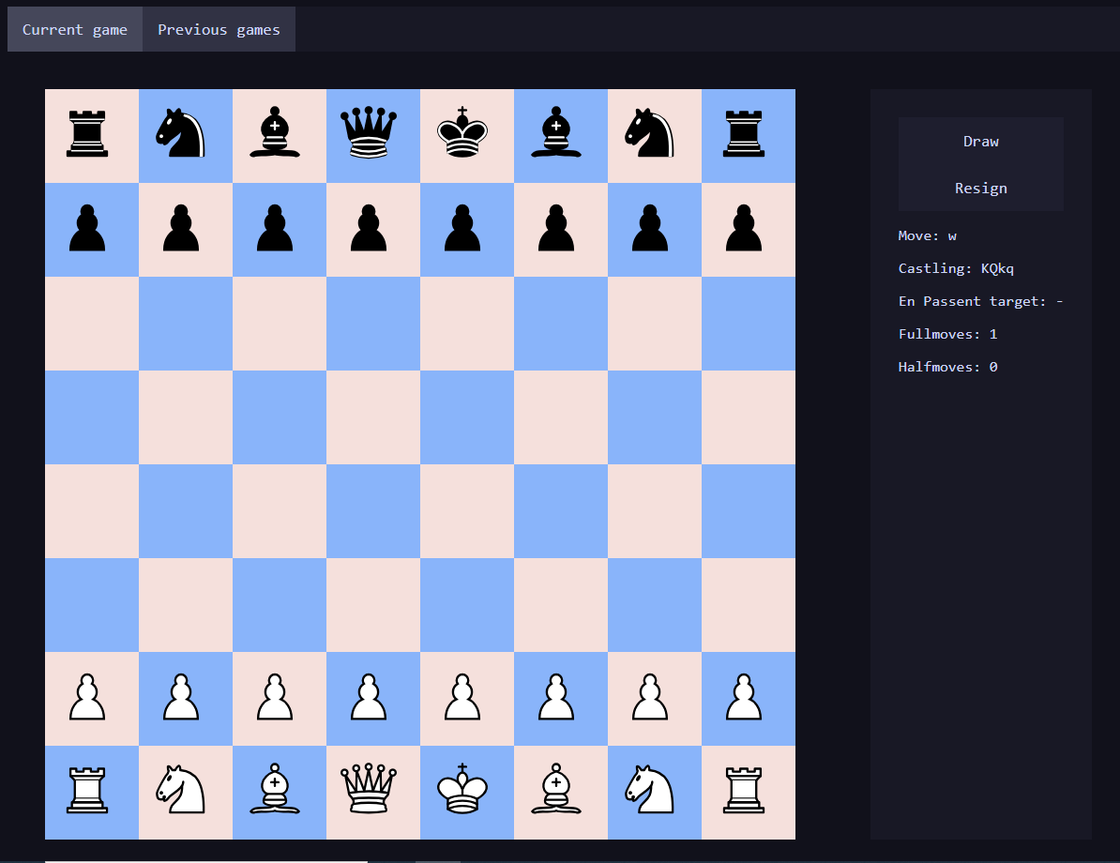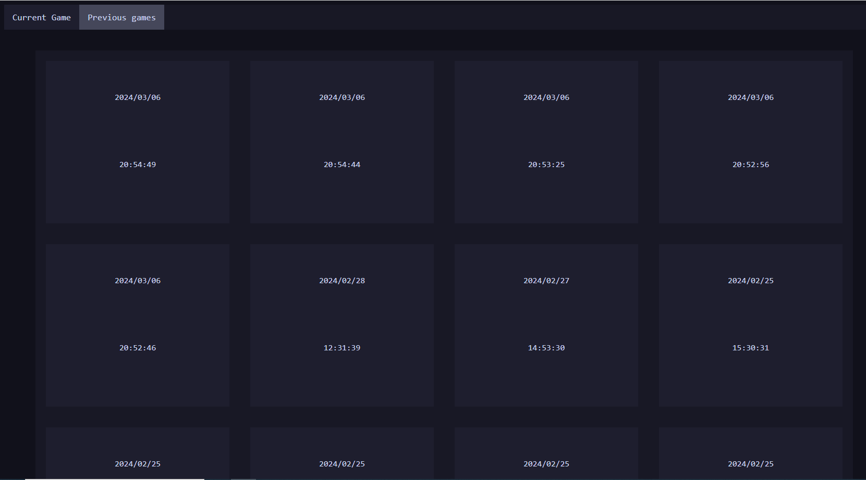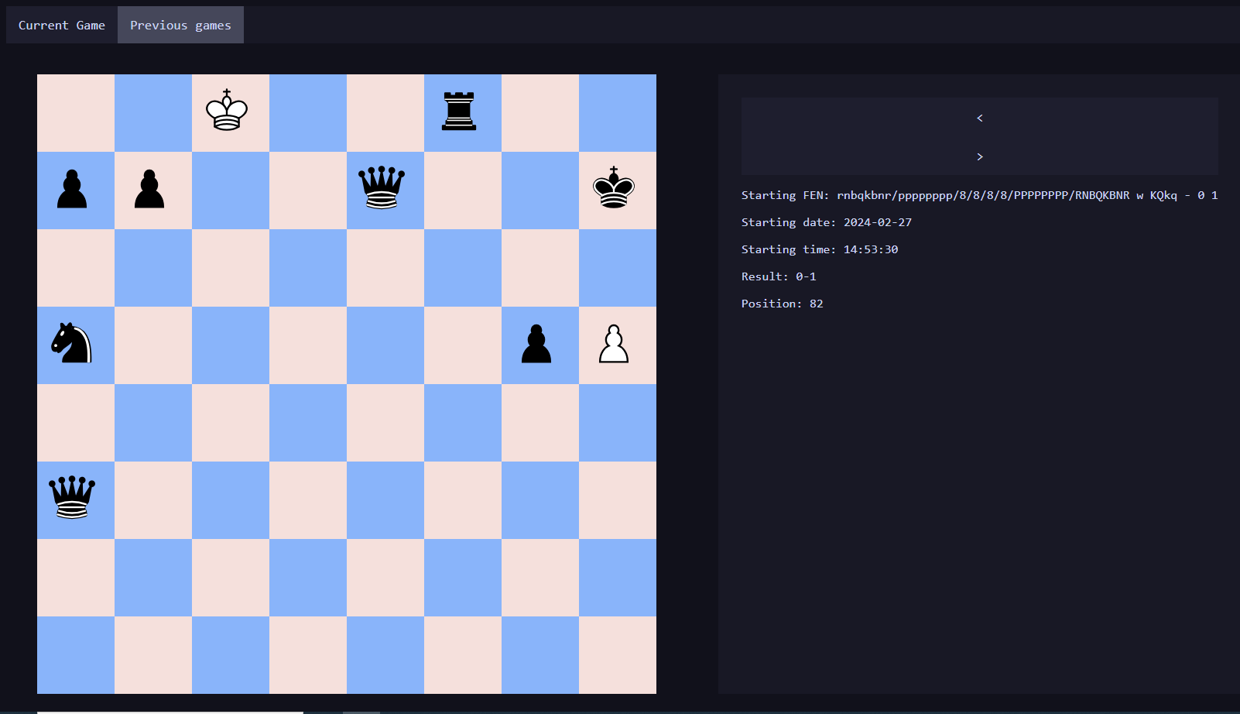

# Research and development of new skills and/or knowledge

HTTP Requests

In order to implement the user interface of this project, further knowledge of HTTP requests was required. This is because my UI is a website that needs to be served by a HTTP server, which is something that is not taught in AH, as only basic HTTP requests using HTML forms and php is taught, which we had not started learning when I started implementing the UI, which was done early (as it made it much easier to do ongoing testing). The way I applied these skills that I developed was by using Python’s http.server module, in order to create a simple HTTP server that could respond to GET and POST requests. I created a class which extended the HTTPServer class, where I added an array called handlers, which I used to faciliate a more logical way, from an object orientated perspective, to serve multiple webpages, resources (such as .css files), and api endpoints. These api endpoints faciliated the communication between the webpages, which used JavaScript, and the Python side of the program. This allowed for inputs on the webpage to be sent to the Python side of the program for validation, which allowed for chess moves to be played and such, which is obviously an intergral part of this program.

I learned how to use the http.server module from the official python documentation at <https://docs.python.org/3/library/http.server.html>, and I learned more general HTTP related things (like response codes, and headers) from the Mozilla web docs at <https://developer.mozilla.org/en-US/docs/Web/HTTP>

JavaScript

In order to create the user interface for this project, by sending HTTP requests to the endpoints for playing chess moves or for getting the positions of a specific previous game, JavaScript was required. I used this mainly for getting input and displaying output. For example, for the chess board, I wrote a for loop to display 64 squares of alternating colors, with an onclick event listener which would execute some code when a square is clicked (ie when the player is trying to move a piece), instead of writing at least 64 lines of repetitive HTML. As a result, not a lot of html was written in .html files, which made it far easier to implement input and outputs in the ui. The XMLHttpRequest class was used for sending HTTP requests, and receiving responses.

I had previous knowledge of JavaScript prior to this project, but had not used it in many years, and not for this usecase. I relearnt JS mainly from <https://www.w3schools.com/js/default.asp>.

## Log of ongoing testing

| **Date** | **What I am testing** | **Description of issues I met during testing** | **Description of how I resolved these issues** | **List of references I used to resolve each issue**  **e.g.** |
| --- | --- | --- | --- | --- |
| 24/11/23 | Basic http server – testing to ensure that http server is receiving requests ect | None – code worked as expected |  |  |
| 26/11/23 | Tested basic webpage with css and js | None – http server worked as expected, and webpage functioned as expected |  |  |
| 28/11/23 | Test HTTP server and api endpoints | Minor errors with api endpoint – trouble with url parsing | Looked at python documentation | https://docs.python.org/3/library/urllib.parse.html  Accessed 30/11/23 |
| 02/12/23 | Tested FEN parsing | Syntax errors and such (from writing code at 2am) | Fixed the syntax errors |  |
| 05/12/23 | Tested displaying the chessboard with pieces from the FEN displaying on the webpage | Some issues with 0 0 on the board array being a8 square, while was being displayed on the web side with the pieces the wrong way around | Added a lot of board[7 – row][col] to fix this |  |
| 08/12/23 | Added basic moves with no validation | Would move the wrong pieces, for example playing e6 as white would move black’s e7 pawn to e5 | A lot of board[7 – row][col] again |  |
| 10/12/23 | Added validation to ensure that players could only play when it is their turn | The turns did not switch so black could never play a move | Added one line of code I forgot |  |
| 12/12/23 | Tested validation to ensure own pieces cannot be captured | None |  |  |
| 18/12/23 | Tested rook move validation | Was not working as intended due to an unknown bug, which turned out to be in the FEN parsing | Fixed the next day |  |
| 19/12/23 | Tested FEN parsing (again) | Due to a small part of code omitted the parser set board[0][0] to a1, when it should be a8 | Fixed the typo. This also fixed rook moves |  |
| 21/12/23 | Tested pawn move validation incl en passent | Worked perfectly |  |  |
| 24/12/23 | Implemented bishop move validation | Worked perfectly |  |  |
| 28/12/23 | Implemented queen move validation | Worked perfectly |  |  |
| 31/12/23 | Implemented knight move validation | Due to typos (mixing up rows and columns) the move validation failed | Fixed these typos |  |
| 10/01/24 | Started testing file io | No errors |  |  |
| 16/01/24 | Tested FEN and JSON and Position parsing | Due to a small amount of errors that only became apparent when the code was actually important for the functioning of the game, previous games were not displayed properly, with the board missing pieces when numbers were used in FEN rows (ex 4P3) | Fixed the bugs which were programmed in months ago, which also fixed the board for previous games not displaying properly |  |
| 20/01/24 | Tested that new webpages were displaying properly | Works fine but looks terrible cuz no styling |  |  |
| 08/02/24 | Implemented checkmate and stalemate | Some errors due to oversights in logic. | Fixed by rewriting code in question |  |
| Program finished (so I thought, further testing is in testing section) | | | | |

# Testing

## Final test plan

|  |  |  |
| --- | --- | --- |
| End user requirements | Tested | Comment |
| The user can play a game of chess against an opponent | Tested, the user could play a game of chess | It was fine |
| The user can see games they have previously played | Worked as intended | It was fine |
| The players should only be able to play legal moves | Legal moves could not be played | Not all moves were tested (64*64 possible moves that could be attempted per move), but seems to work properly |

| Functional requirements | Tested | Comment |
| --- | --- | --- |
| The main page contains the board, and a button to the previous games page | The main page contains this | It was fine |
| The main page contains buttons that will draw or resign the current game | The main page contains the buttons, and the functionality of these buttons have been tested in many games | It was fine |
| The previous games page should have all previous games, sorted by most recent first, and a link to the main page | The page contains all previous games, and is sorted properly | It was fine |
| Each game button displayed on the previous games page should link to the page for that game | Each button links to the page for that game | It was fine |
| The previous game page should contain a board, and information on the game | The previous game page for a game contains the required information | It was fine |
| The previous game page should have two buttons to change the position viewed of the game | The page contains buttons to view each position | It was fine |
| The HTTP server should serve the webpages | The HTTP server serves the webpages correctly | This was tested by just using the website – if the HTTP server did not would the website would not be able to be viewed |
| The HTTP server should have endpoints for getting data for the current game, and previous games | The HTTP server has these endpoints, and they function correctly | This was tested by testing the functional requirement of being able to view previous games |
| The HTTP server should have an endpoint to update the current game, such that moves can be made | The HTTP server has these endpoints, and they function correctly | This was tested by testing the functional requirement of being able to play a game of chess |

Sub-tests

|  |  |  |
| --- | --- | --- |
| Test | Result | Comment |
| Check that checkmate is recognised in a variety of positions | Checkmate was not recognised in the well known “fool’s mate” position  See evidence for more results  Ultimately sucessful | The reason behind this failing was found – in the function to check if it was checkmate, it was checking to see if checkmate could be blocked, but was checking for the wrong color of pieces, so the checking piece could block it’s own checkmate – this bug was fixed.  See evidence for more comments |
| Check that stalemate is recognised in a variety of positions | Stalemate is recognised in a variety of positions | Stalemate worked first try with no fixes to code needed, apart from one typo |
| Check that the fact that the king is in check is recognised in a variety of positions | This has been tested to work | The fact that checkmate is recognised in a variety of positions implies that check is also recognised, so not much seperate testing was done |
| Check special moves thoroughly, such as castling and en passent | Special moves such as castling and en passent have been tested to work | It was fine |

## Detailed plan for sub-tests

For sub-tests, the initial position of the game will be changed (by editing a string in code) such that the game starts in a position where it is one move to test something like checkmate. This is simply so a large amount of moves do not have to be played to test a single checkmate or stalemate position.

## Persona

## The persona is the user(s), which is the player(s) playing the game against themselves, or against another player. The persona is someone who at least knows the basic rules of chess, and as such can play the game.

Test cases

- The user will test the UI, to ensure that it can be used to navigate the website  
- The user will test the main page, to ensure a full game of chess can be played against another player  
- The user will test the main page (chess game), to ensure that only legal moves can be played  
- The user will test the previous games page, to ensure that they can find a link to a previous game  
- The user will test pages for previous games, to ensure that they can see every position of the previous game

## Requirements testing

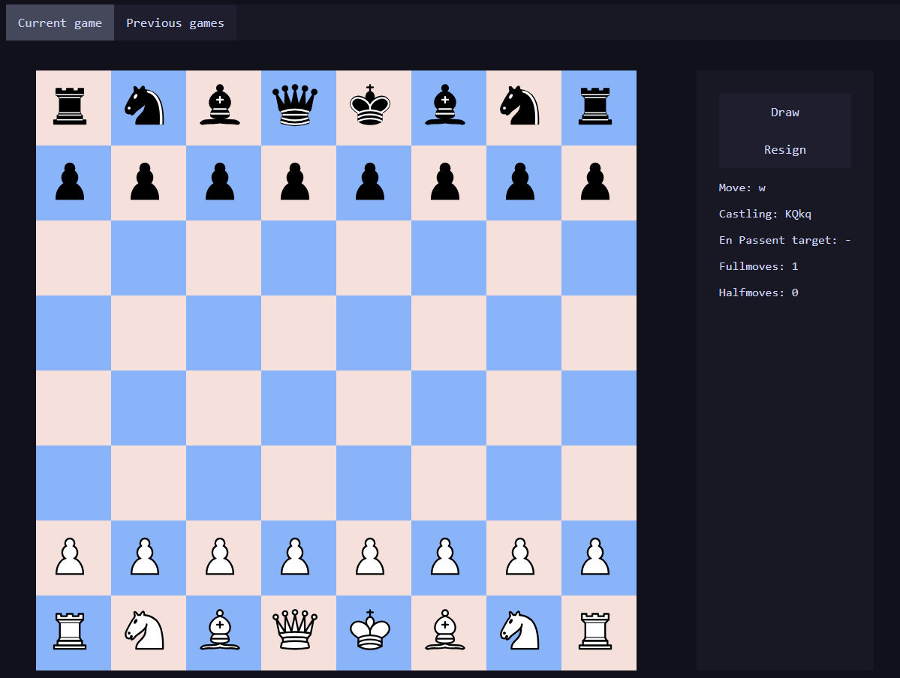Screenshot of main page – all buttons can be seen

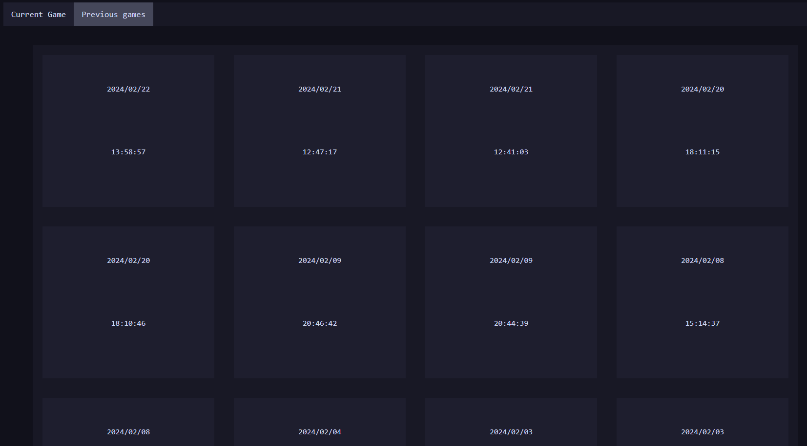Screenshot of previous games page – many previous games can be seen, and they are in chronological order

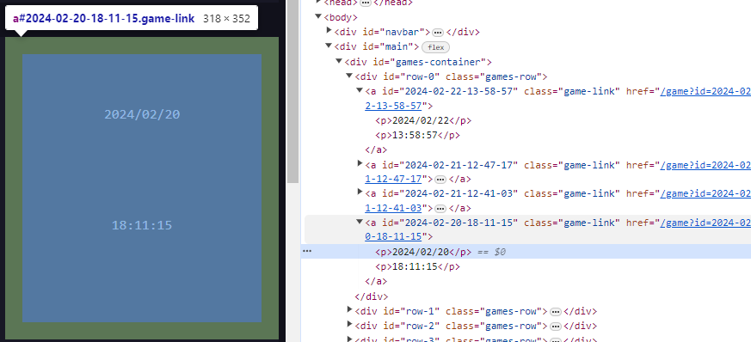As can be seen, the previous game button is an ‘a’ element with a href to the page for the game – it is shown this way because it is somewhat difficult to print out a video showing this, as evidence.

Evidence that the basic moves work

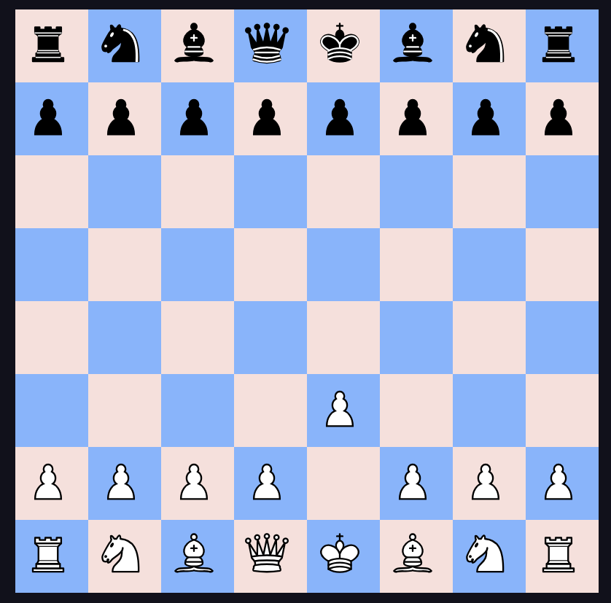

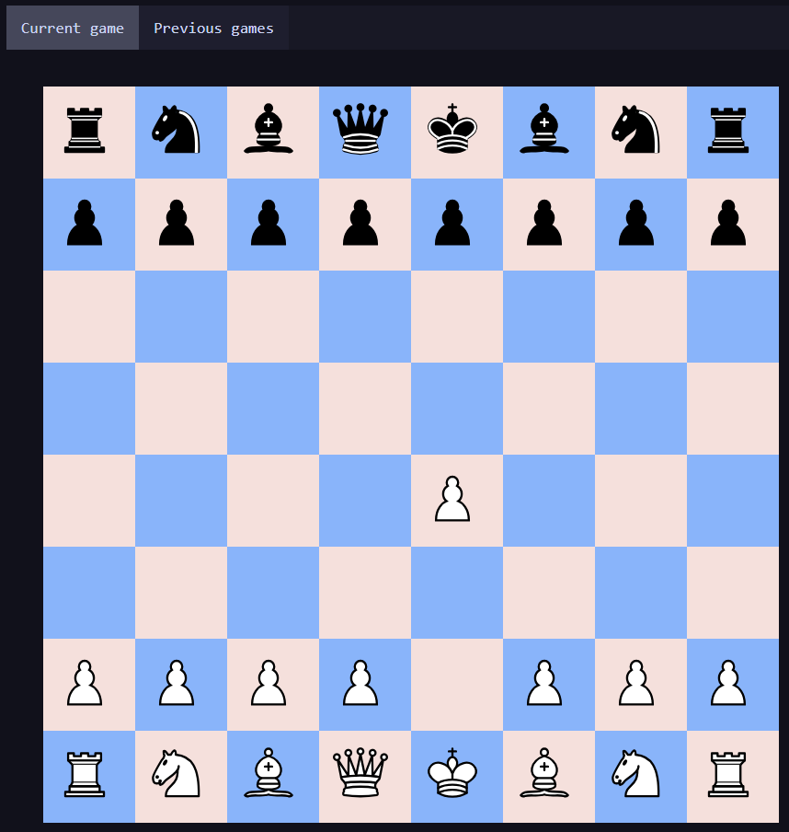

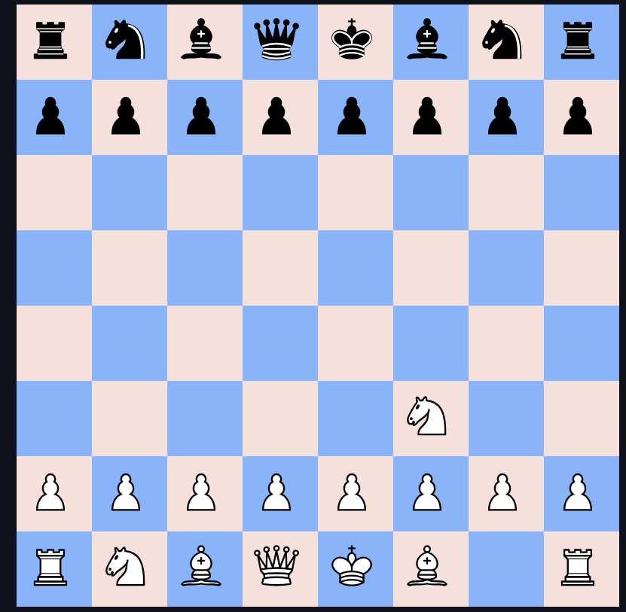

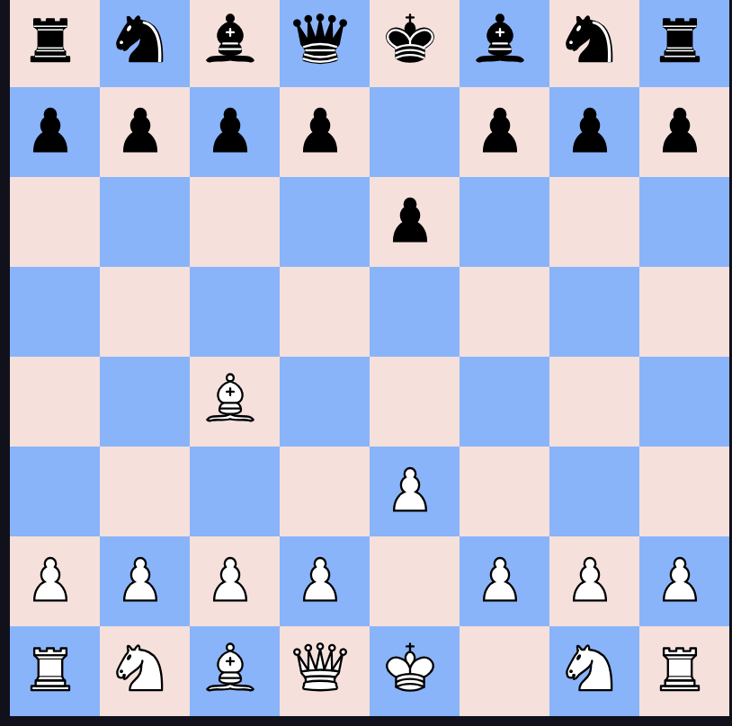

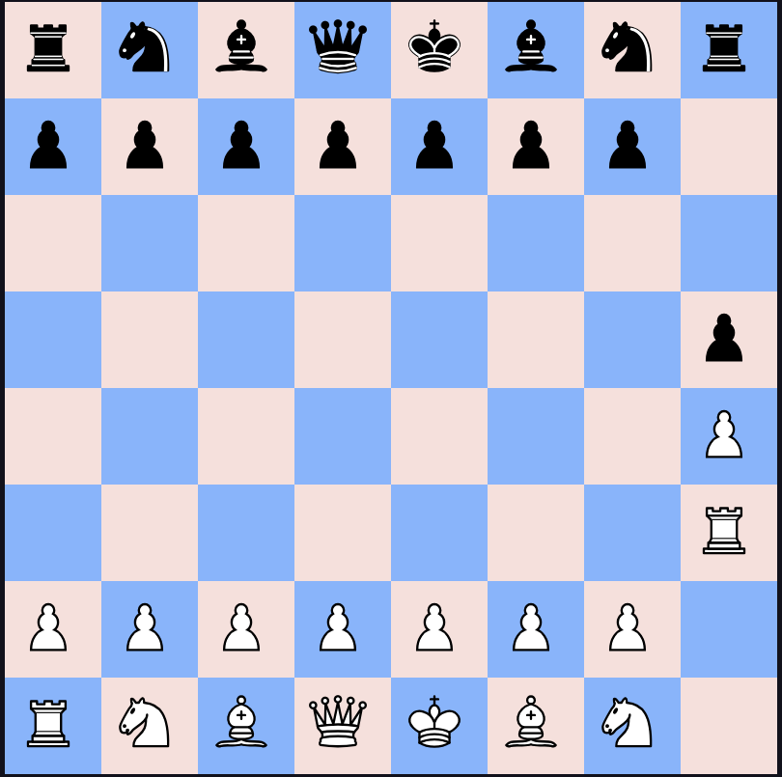

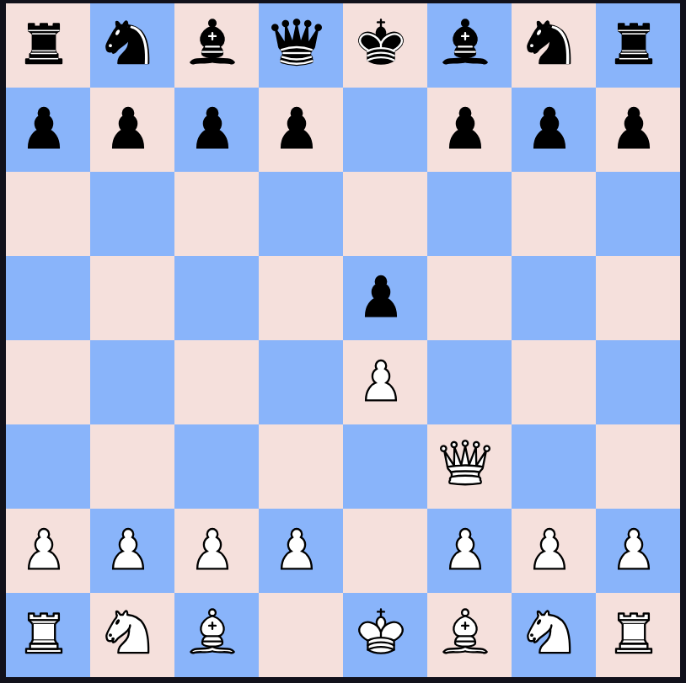

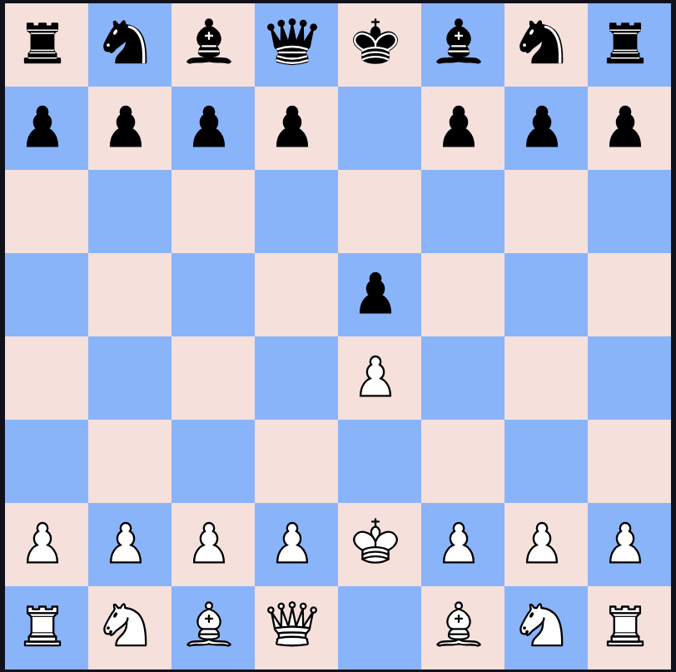

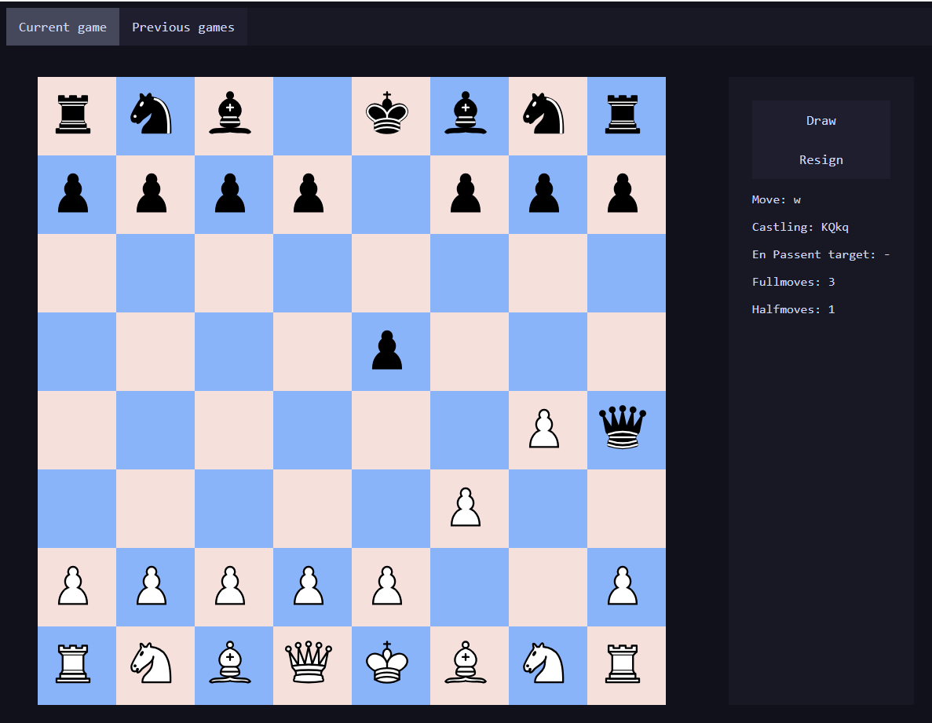This position should be checkmate – this is the “fool’s mate” position. However, it is not detected as mate. This bug was later fixed

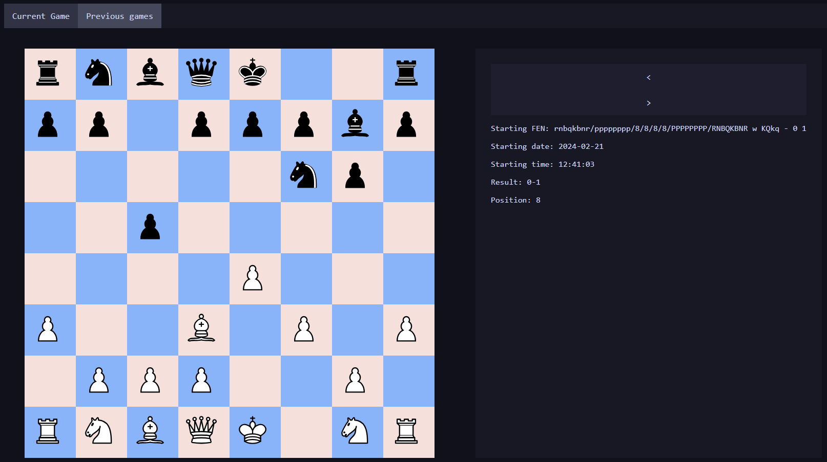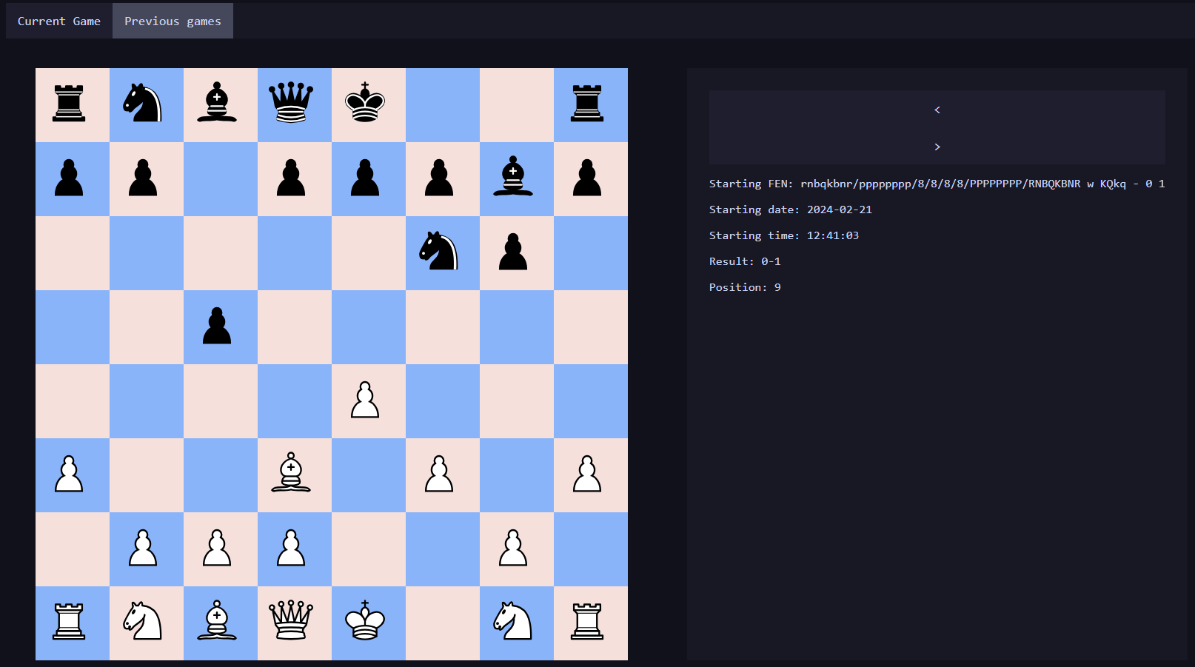Positions 8 and 9 are identical here – this is a bug

## A screenshot of a specific position of a previous game can be seen here

## Evidence that castling works

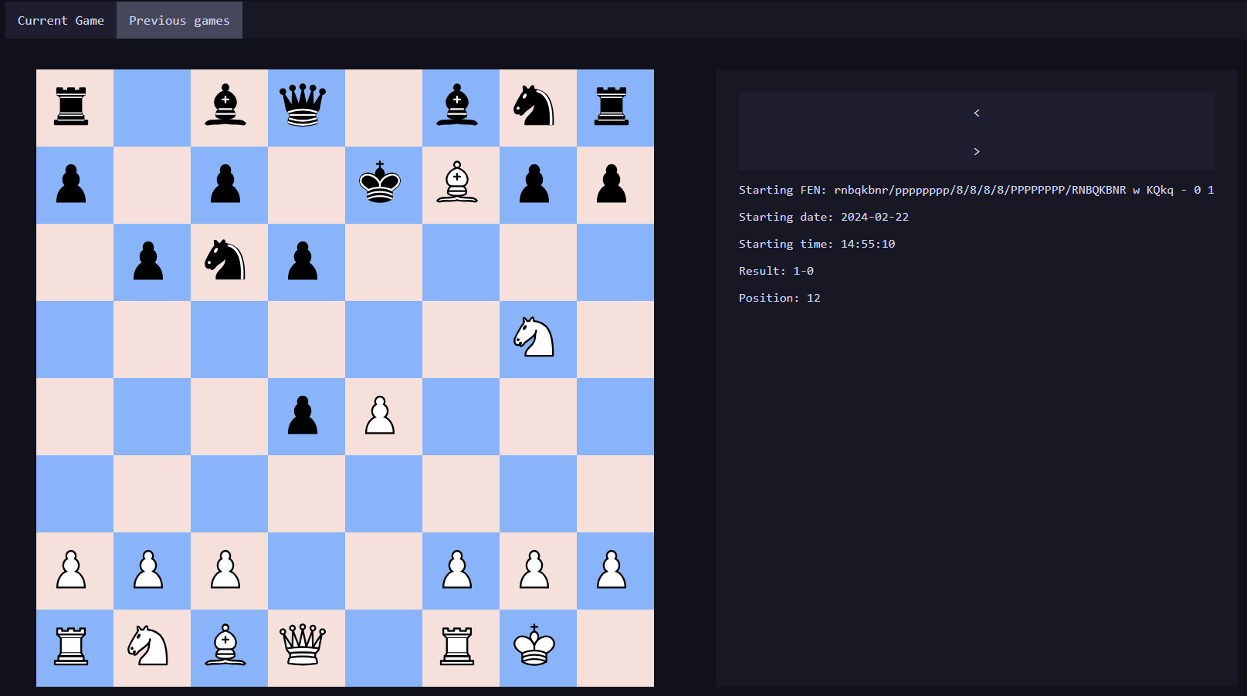

## Fool’s mate checkmate now works – as can be seen by ‘Result: 0-1’

## En passent

In this position, black’s f pawn has just advances 2 spaces, and as can be seen, f6 is now an en passent target.

## 

As can be seen, white’s d pawn was able to capture the f5 pawn en passent, and the en passent target has reset to -

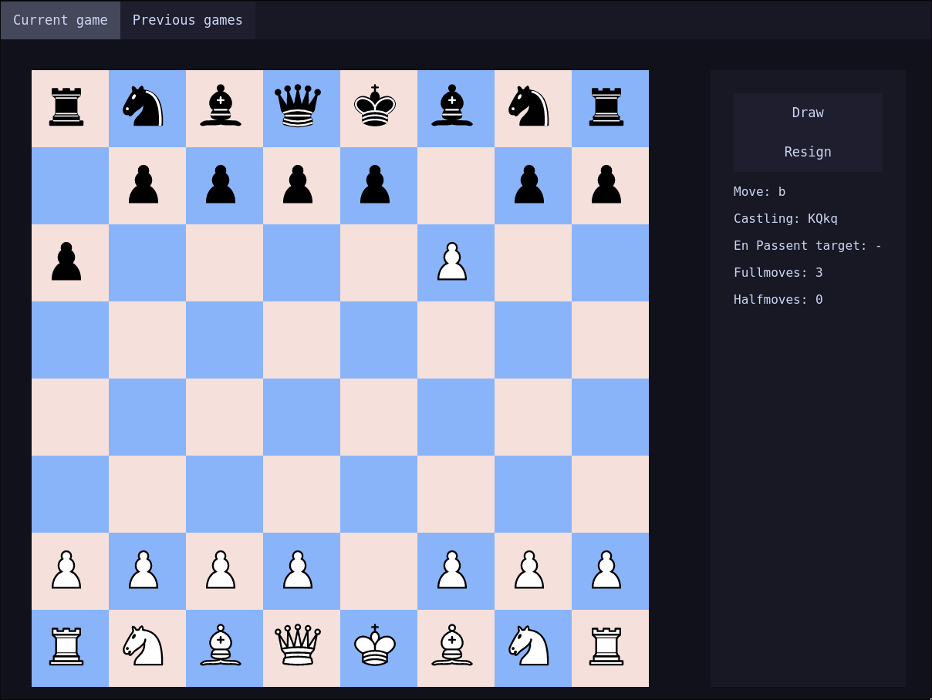

## Testing checkmate

6k1/5ppp/8/n1r5/8/8/3R1PPP/5RK1 w - - 0 1

fails. This should be checkmate

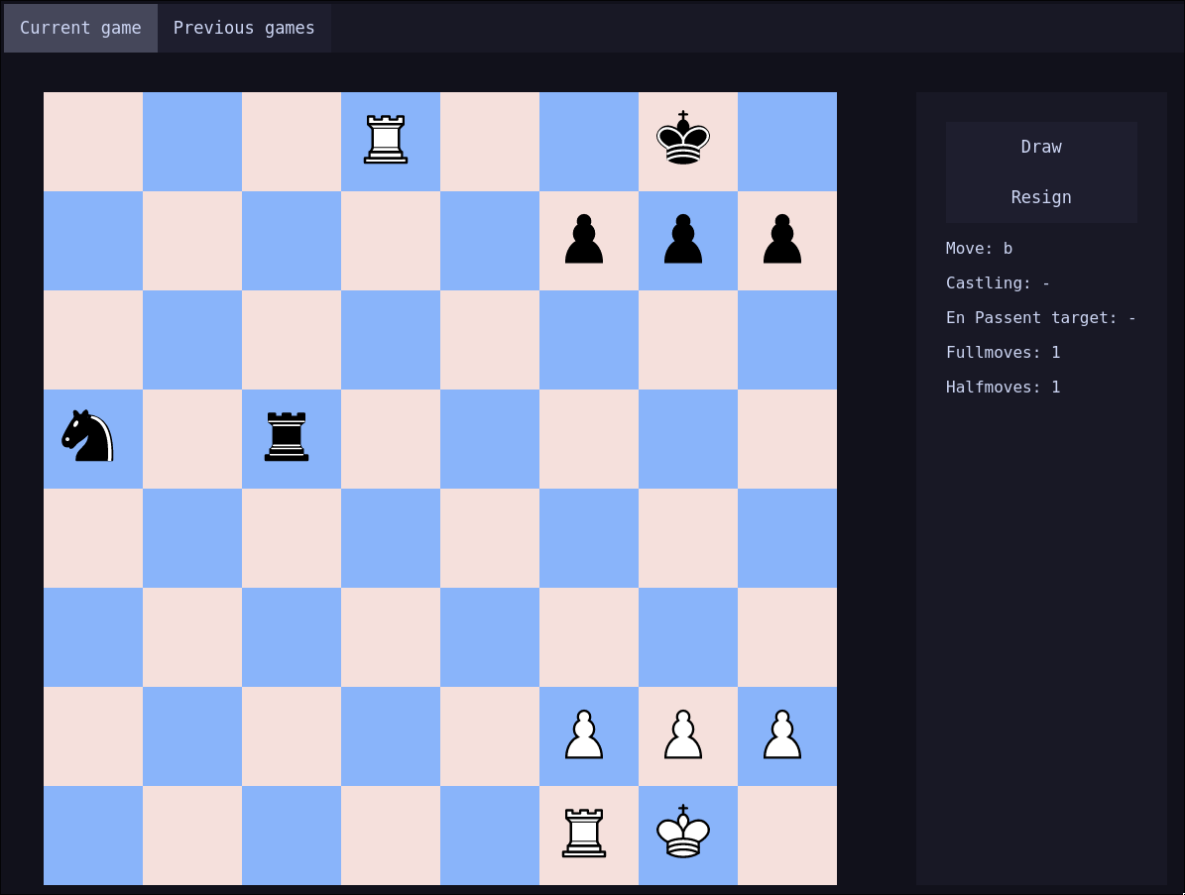

This fails because it sees h8 as a legal square, as if the king were to move there, due to an oversight in code, it would see the king that is currently on g8 as blocking check, therefore not being in mate.

## As can now be seen, this specific bug has been fixed

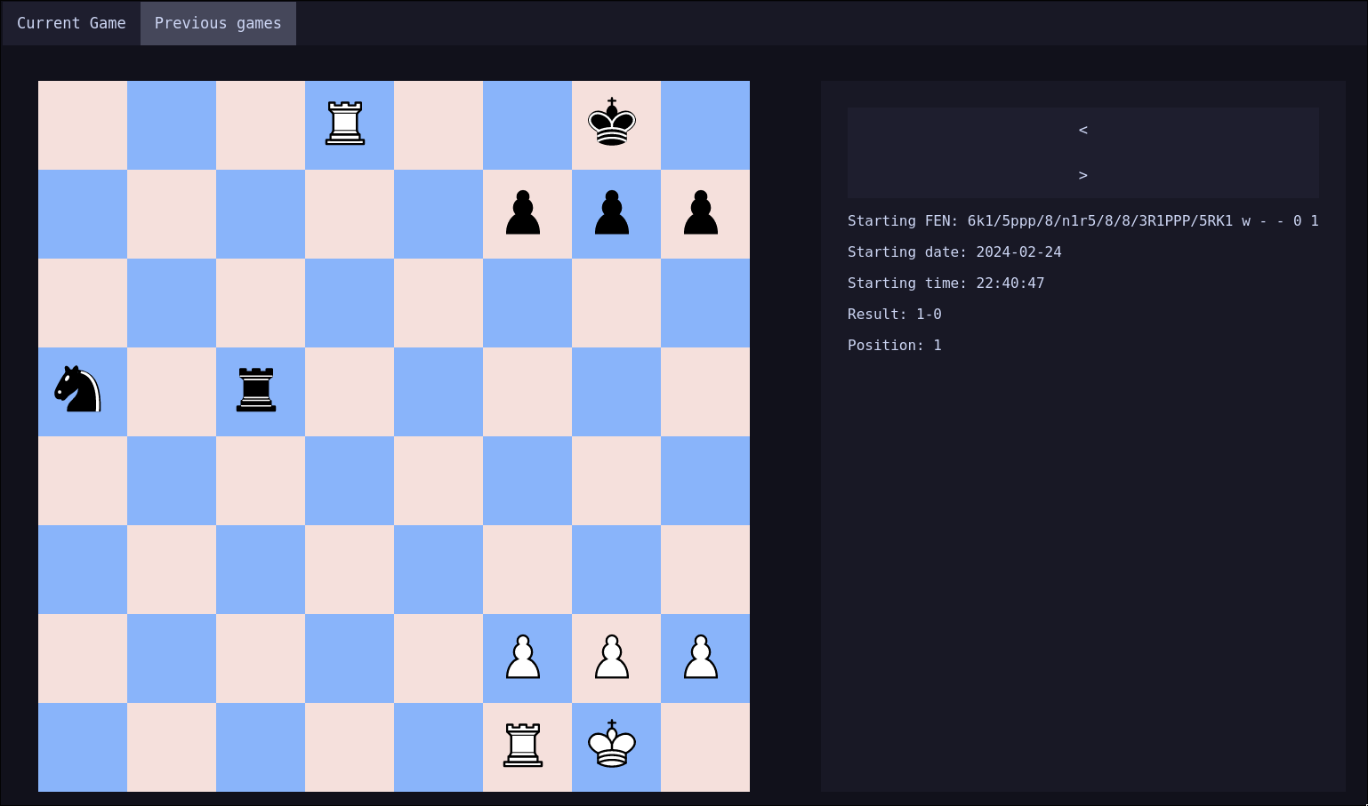

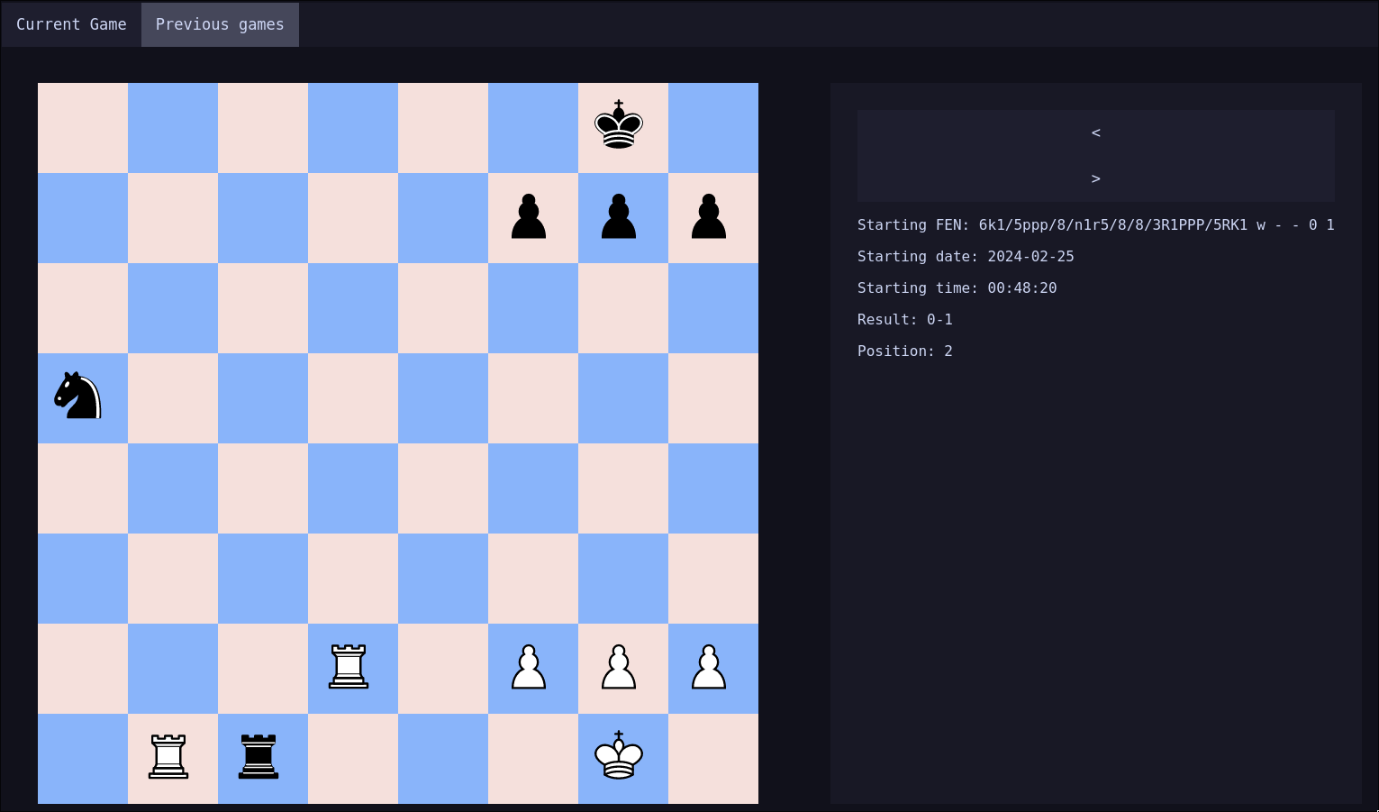Further testing

## This position is recognised as checkmate, even though the black rook could be captured by the b1 rook, or blocked by the d2 rook.

This was due to a small oversight/typo in code, where instead of returning false at a point in the is_checkmate function, it would instead set a variable to false, then the function would continue to conclude that the position is mate.

Evidence that this position now works ( note that this is in the current game window, and thus the game has continued (ie not mate))

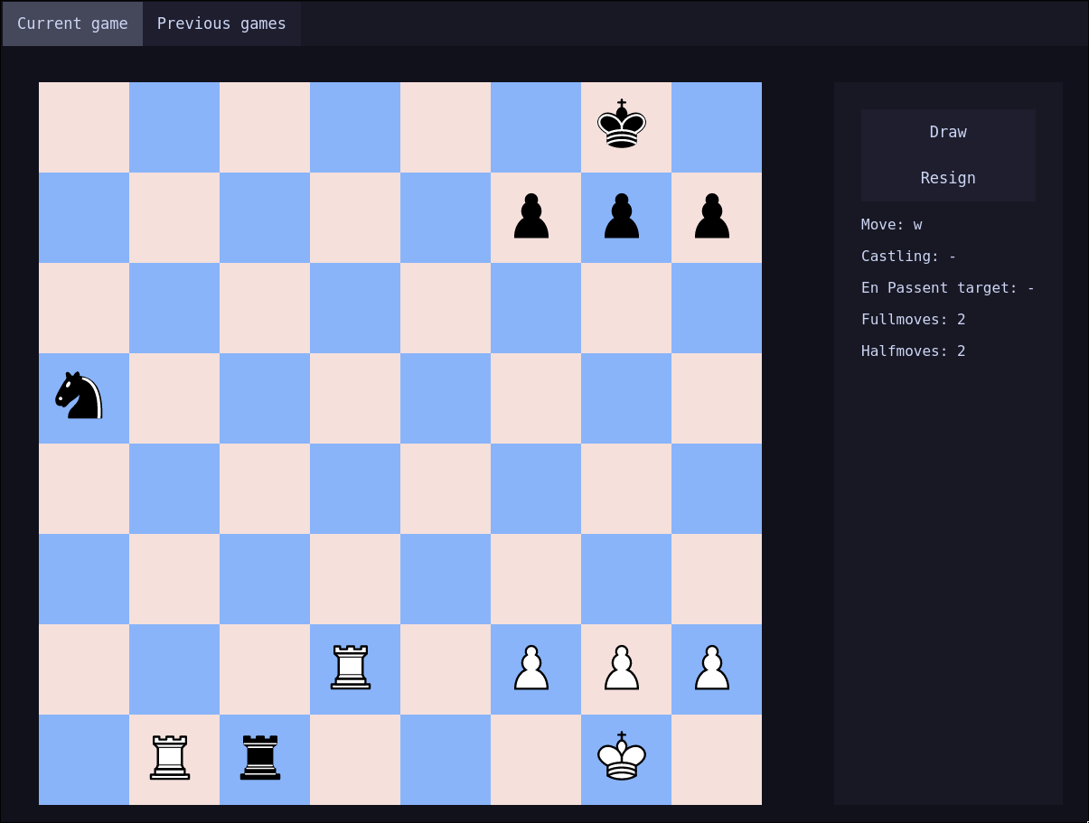

## r3kb1r/pppqBp1p/n2p2p1/2nN1b2/2P5/P5N1/1P1Q1PPP/R3R1K1 w kq - 0 1

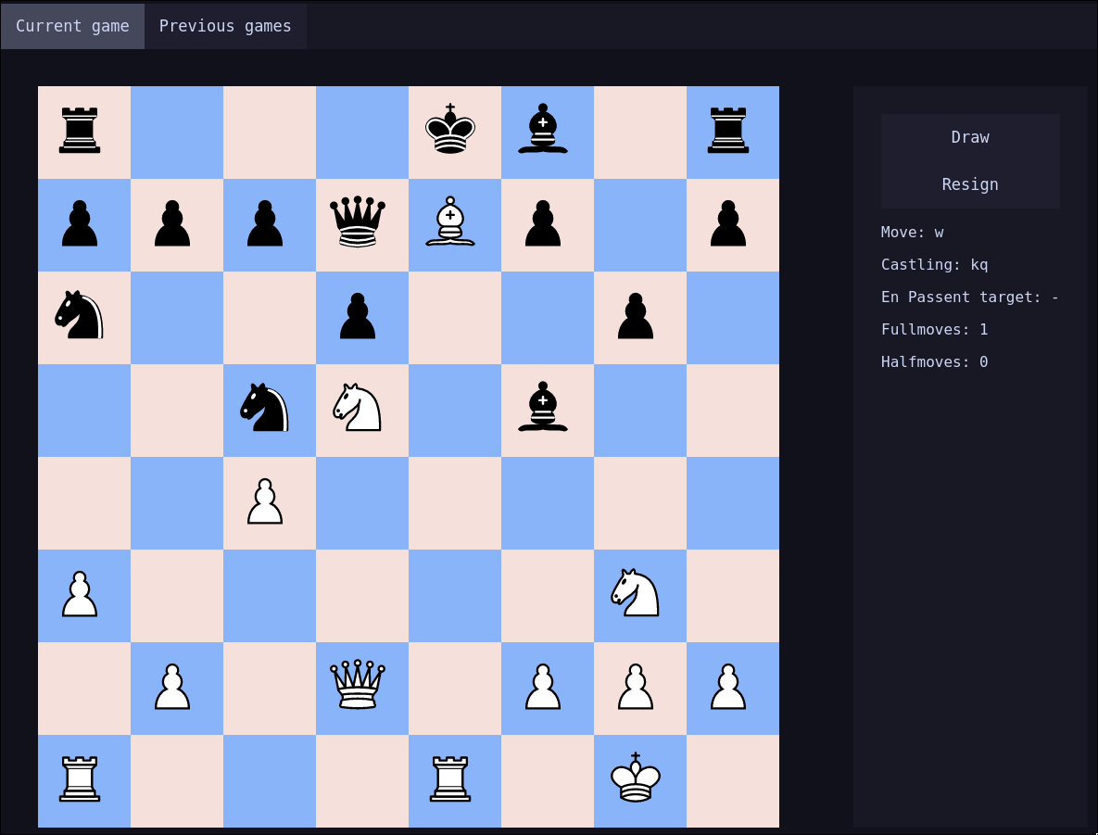

The move Kf6 simply crashed the program here. This was a simple error to fix – it was an error in the is_checkmate function, where I forgot to add two lines of code that would return true if the checking piece could not be captured, and is a pawn or knight, as pawns and knights cannot be blocked.

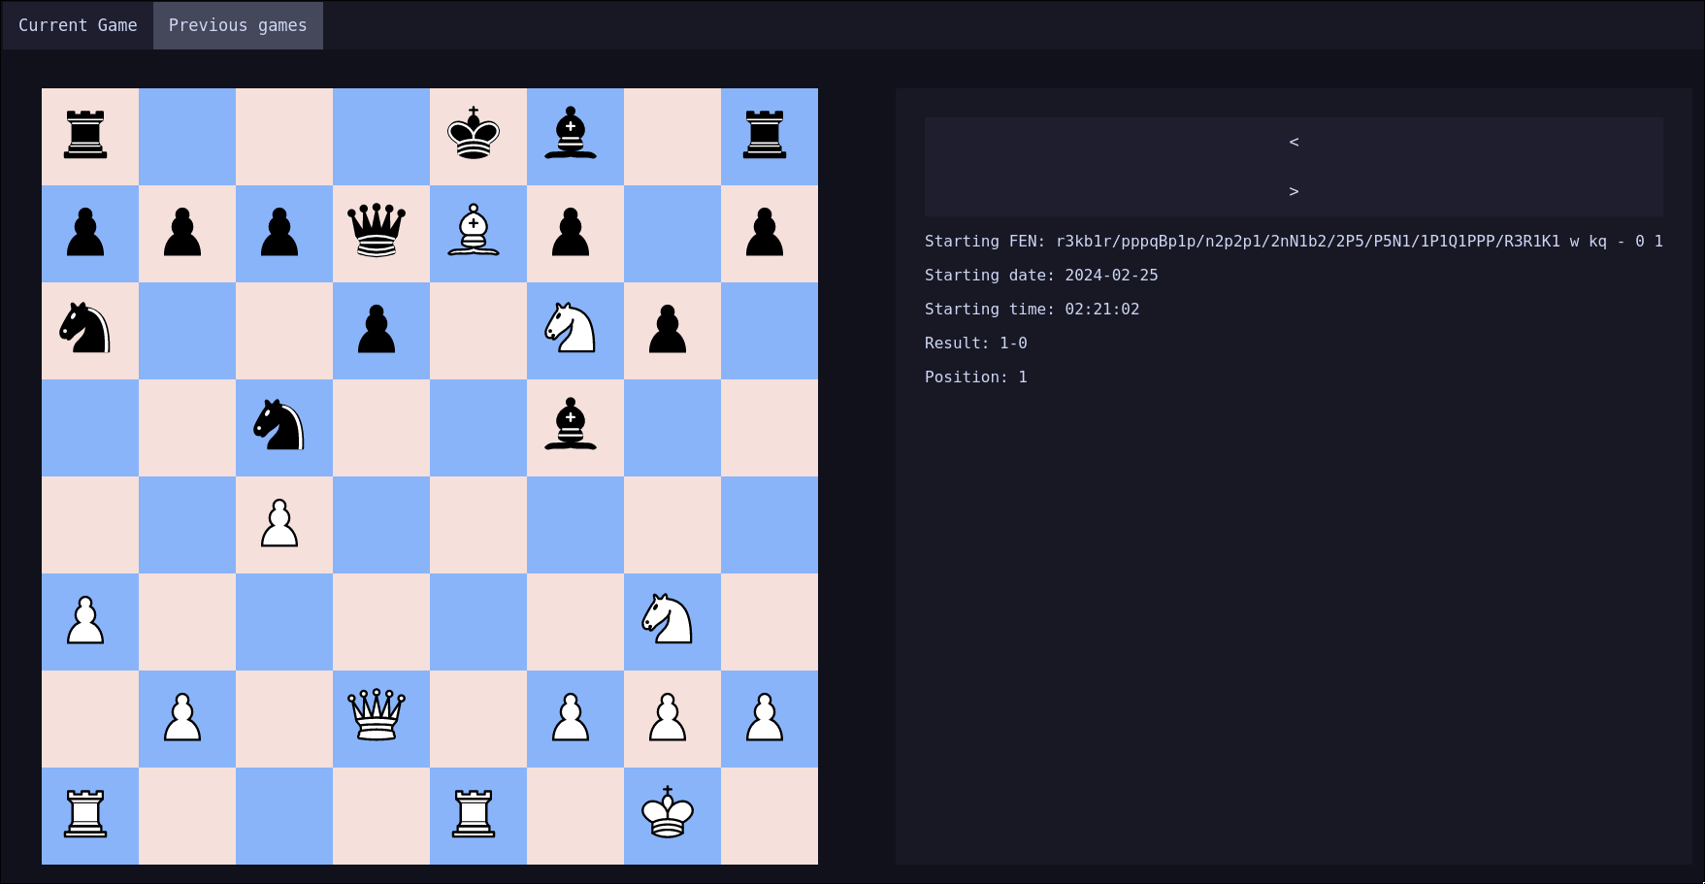This is evidence that this now works

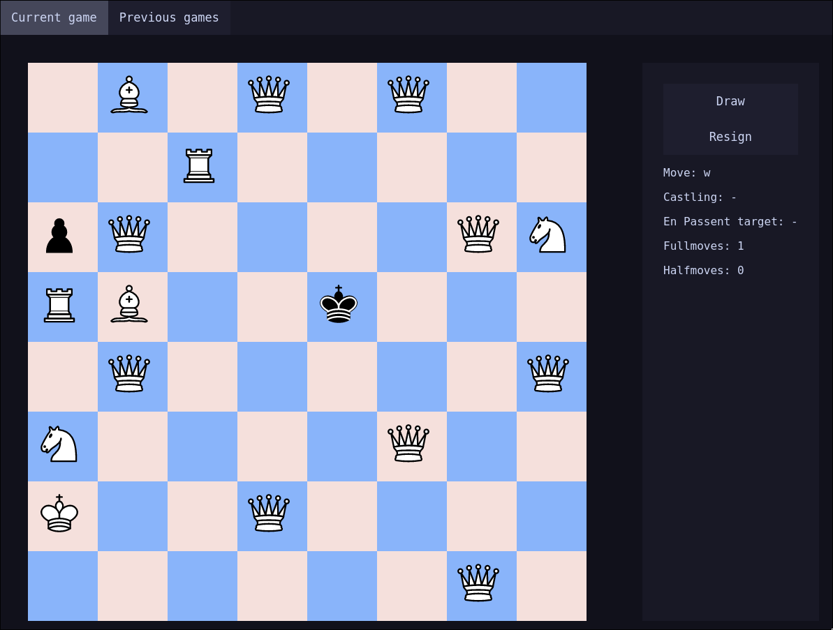1B1Q1Q2/2R5/pQ4QN/RB2k3/1Q5Q/N4Q2/K2Q4/6Q1 w - - 0 1

This position had no errors in detecting checkmate, and multiple of the various checkmate options did result in mate

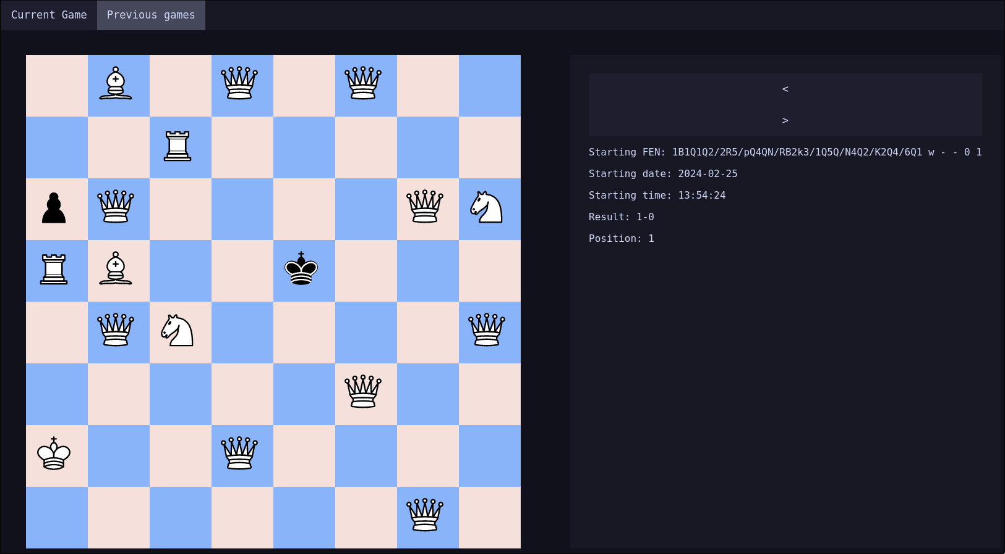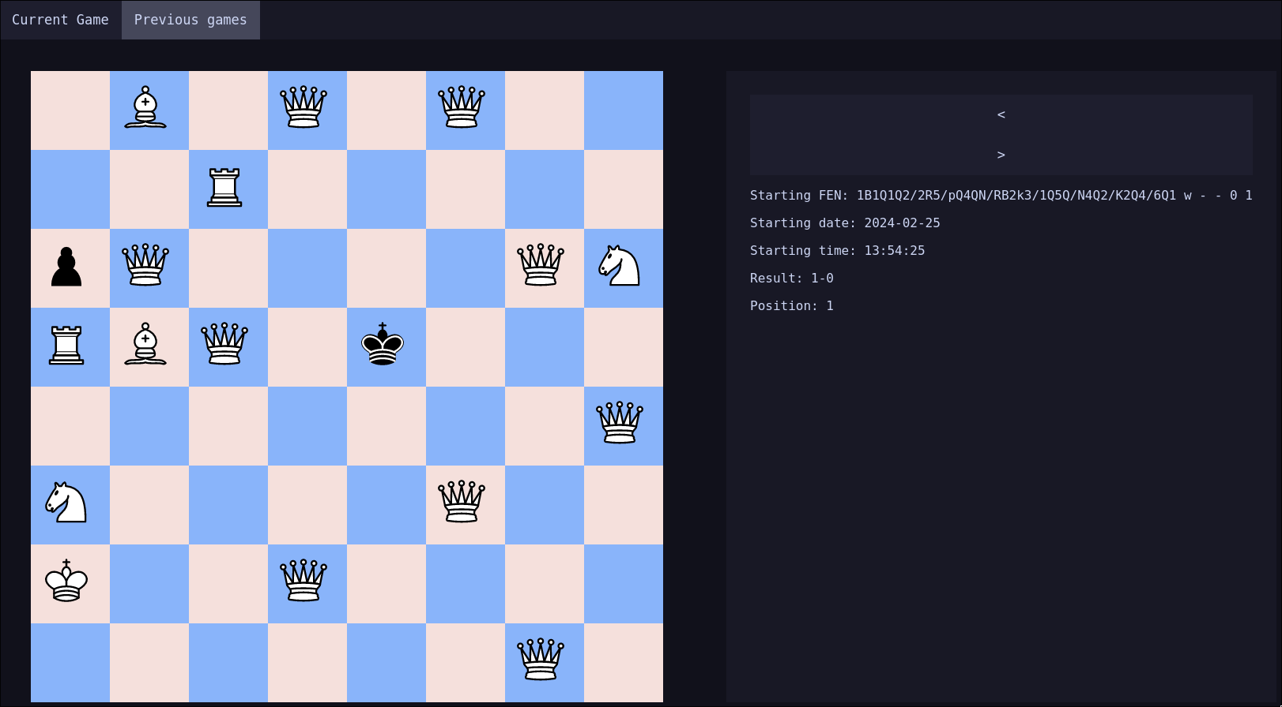

## kN6/P1PPPPPP/2P5/4K3/6Q1/2NBB3/1R6/R7 w - - 0 1

## (stalemate in 1)

## 

## The move a1 to a2 was recognised as stalemate

## 

## As was the move Ka7

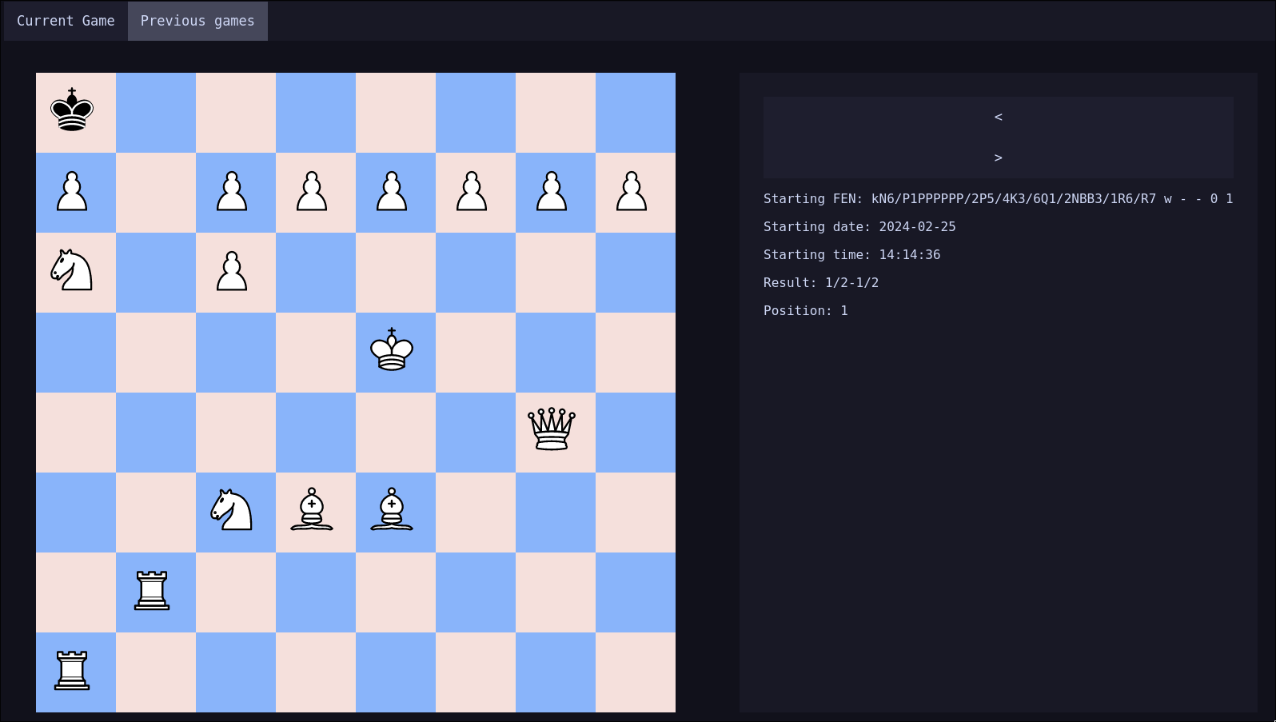

## R6B/3Q4/1Q4Q1/4Q3/2Q4Q/Q4Q2/pp1Q4/kBNN1KR1 w - - 0 1

Stalemate in 1

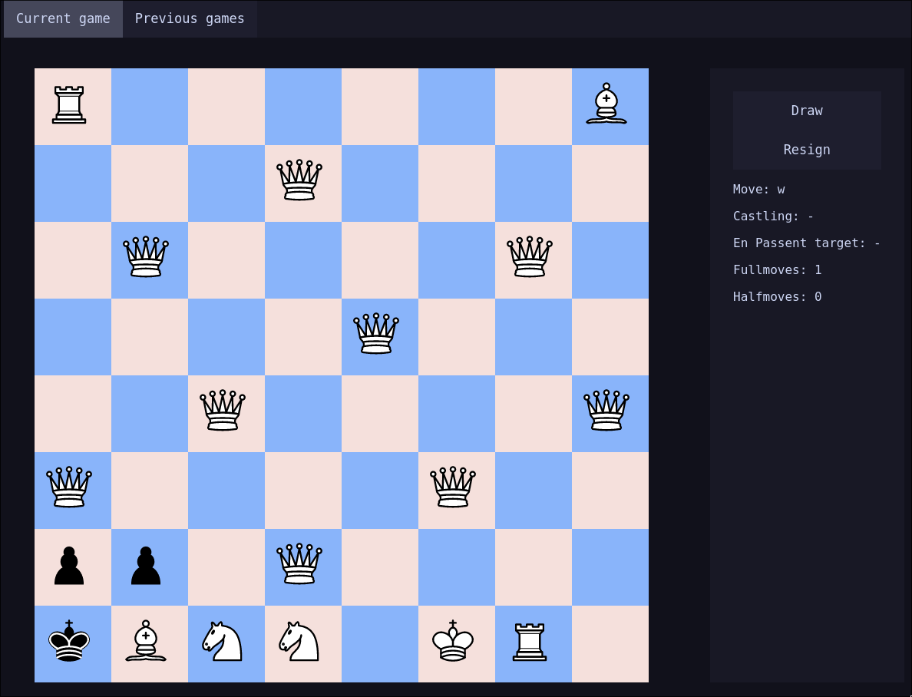

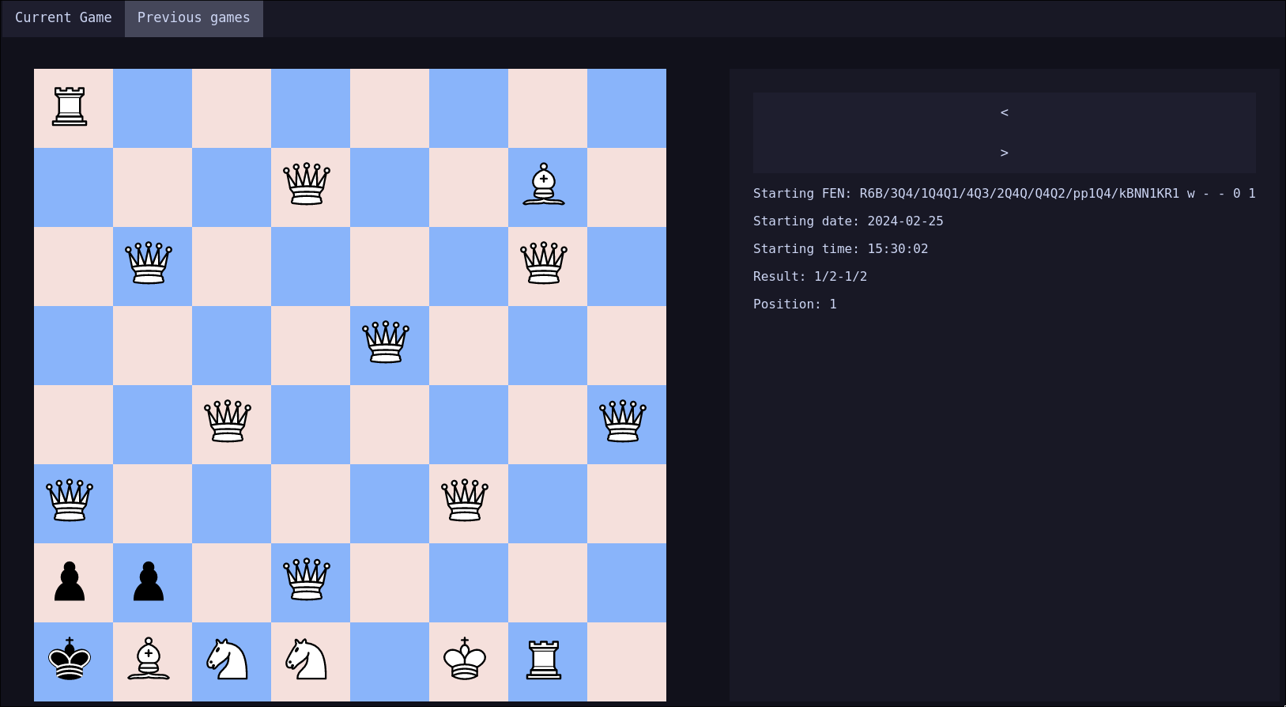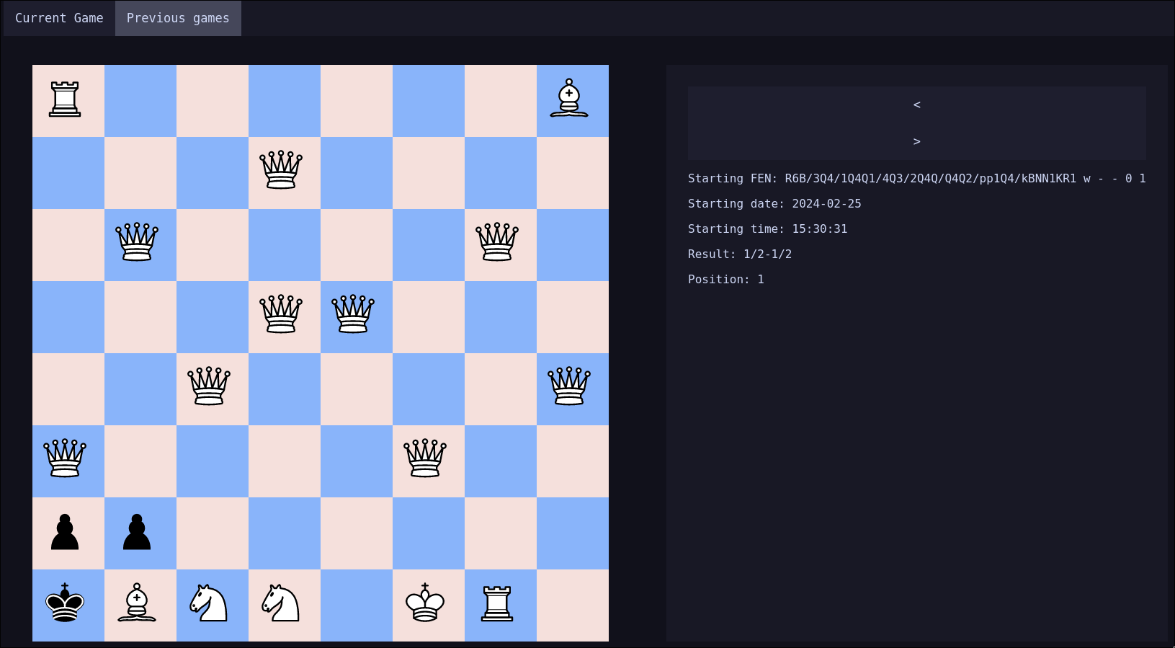As can be seen, there are many moves that will cause stalemate (Kb3 is mate, and this also works)

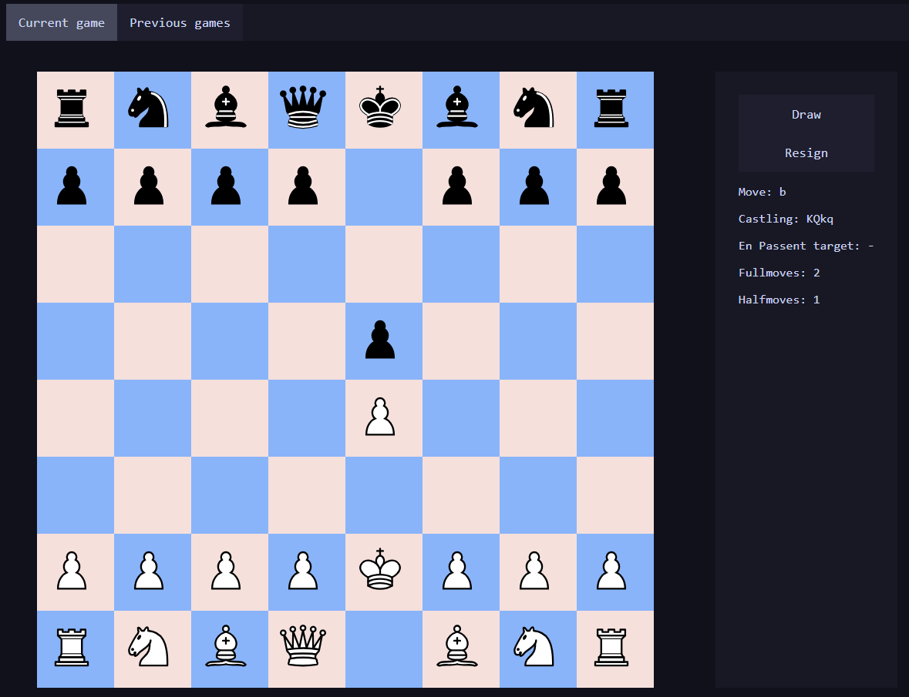A bug was found where the castling legality was not updated after a king move

This was simply due to an oversight in the code, and was easily fixed

## A screenshot of a computer game Description automatically generatedThis position should have been recognised as checkmate

As can be seen, this checkmate position now works properly. This bug was because the program thought the king could capture the checking queen, when it couldn’t

## Testing with persona and test cases

Two classmates tested with the persona – classmates are labelled 1 and 2

|  |  |  |
| --- | --- | --- |
| Test case | Result | Comments |
| The user will test the UI, to ensure that it can be used to navigate the website | 1 – The UI worked correctly, and all pages could be navigated to  2 – The UI was easy to use and worked | It was fine |
| The user will test the main page, to ensure a full game of chess can be played against another player | 1 – A full game of chess could be played against me  2 – A full game of chess could be played, and lost, against me | This was prior to finding the bug with certain checkmate positions, and the checkmate in this game did work as intended |
| The user will test the main page (chess game), to ensure that only legal moves can be played | 1 – only legal moves could be played (checking as much as is reasonable)  2 – only legal moves could be made | It was fine |
| The user will test the previous games page, to ensure that they can find a link to a previous game | 1 – the user could view the game they just played against me  2 – the persona could find the link to the page for the previous game | It was fine |
| The user will test pages for previous games, to ensure that they can see every position of the previous game | 1 – the user could view each position of the game they played against me  2 – the persona could view each position of the game | A bug was found where some positions were exactly the same as previous ones – ex positions 21, 22, and 23 would be identical, though every position could still be viewed. This was discovered to be because illegal moves were played, and although the move failed validation, it was still added to the position json |

# 

# Evaluation

## Fitness for purpose

This program is fit for purpose, as is shown by the testing. As per the requirements set out in the analysis of the project, all inputs are validated, and the user can play a full game of chess against themselves or an opponent using the same computer, with all inputs validated. The user can look back at this previous game, and other previous games, and view each position of the game from the start to the end. Persona testing showed that all aspects of the UI (the integration) worked perfectly, after some minor bug fixing.

All the tests listed in the test plan have been carried out, and the persona tests have shown that players were able to successfully use the UI, and play a game of chess, and view previous games.

|  |  |
| --- | --- |
| Functional and end-user requirements | Met? |
| The user should be able to play a game of chess against themselves or another person using the same computer | Y |
| The user should be able to see previous games using the user interface, which should be sorted by most recently played. The user should then be able to see each move of that game. | Y |
| The user should be able to make chess moves in an intuitive way by clicking on the square with the piece they wish to move, then they click on the square they want to move the piece to | Y |
| The user should only be able to make legal moves, so all moves will be validated | Y |
| The main page should have a game board, buttons to draw or resign the game, and a link to the previous games page | Y |
| The previous games page should have a list of all previous games, sorted by most recent being first, with each previous page linking to the previous game page for that game. It should also contain a link to the main page | Y |
| The previous game page should have a game board where the player will not be able to make moves, two buttons, one to go forward a move and one backwards. It should also contain a panel at the side containing info about the game, such as who won. | Y |
| The HTTP server should serve the webpages for the UI, have endpoints for getting data about previous games and the current game, and have an endpoint for playing a move in the current game. | Y |

## Maintainability

This program is maintainable and upgradeable. Meaningful variable names have been used, and comments have been used when the code is not self explanitory by simply reading it – this is mostly in the move validation. As can also be seen, whitespace is used to seperate code, making it more readable and thus more maintainable. Here is an example of all of this

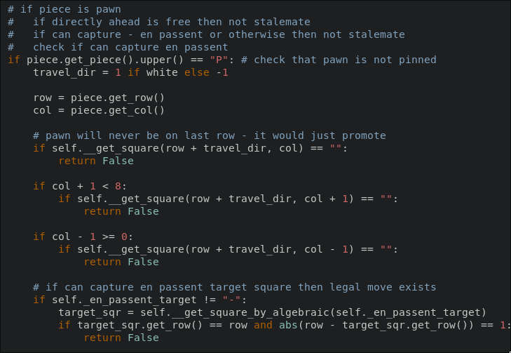

Due to the way that the intergration has been designed, it is simple to add new things, such as a timer to the user interface. This is due to the HTTP server having ‘handlers’, which allows for an endpint for a single file (such as a javascript script) to be made. It is also easy to add these resources to the html file, as is shown here

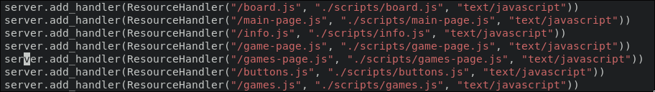

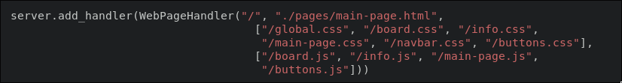

This would allow for new ui elements to be added, as well as new webpages if necessary.

This would allow, with some modification of code, for new features such as timed games to be added.

As is shown here

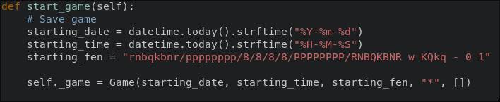

The starting FEN could be editied (this has been done during testing, to speed up checkmate and stalemate testing), to allow for chess variants such as Chess960, which has a non-standard starting position, to be implemented. This would require some modification of the chess code, but would be fairly simple, as rules for moving pieces are the same (apart from castling).

For the move validation, seperate functions were used for each piece, as evidenced here

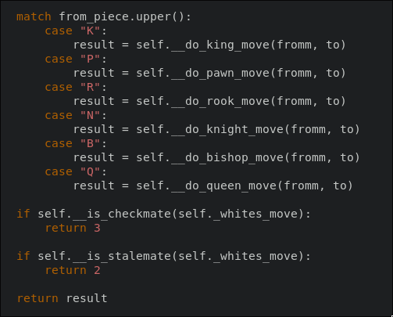

This means that if a bug were found in the move validation for a piece (extremely unlikely), it could be easily fixed. More likely, if a bug were found in the checkmate or stalemate validation (unlikely, but possible), it could be fixed without impacting the other code in the validation (as long as the checkmate/stalemate function was where the bug was)

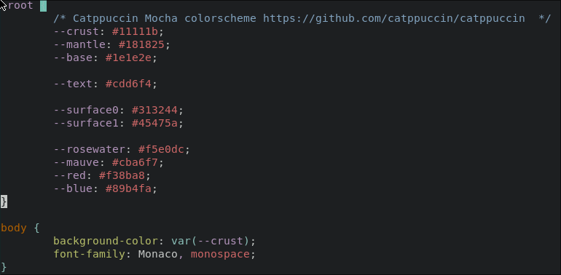For the intergration, a global.css file was used so that colors are consistent across all pages. This means that the color of the pages can be changed very easily, all from one file.

However, the variable names for some colors (‘red’ for example) implies that this color is red. This means that if the color was changed, it would not be as obvious what color it is, and changing the variable name would require changing all instances of its usage.

Overall, the program is maintainable and upgradeable (to a reasonable extent). The code has been designed in such a way that edits to code are easy to do, which has been critical when bugfixing during the testing phase. Sections of code such as input validation have comments if the purpose of the code is not immediately obvious.

## Robustness

The program is robust – it validates all inputs, which in this case are just the player moving a piece – all other input is pressing buttons. The move validation has been tested beyond reasonable doubt to be effective, as is shown in the section dedicated to testing above.

A sample of code showing some validation for moves is shown

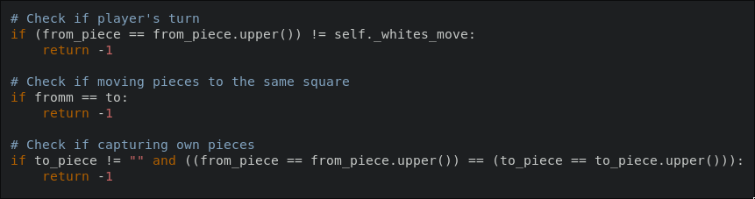This kind of code is used throughout the program to ensure that only legal moves can be made. In this specific snippet of code, it is ensuring that a player is not trying to move when it is not their turn, moving to the square they are already on, or capturing their own pieces.

The testing has shown that move validation functions correctly, and only accepts legal moves. It also ensures that when a position is checkmate or stalemate, the game is ended. However, due to the huge number of possible chess positions where a move could be made, with estimates of trillions of possible positions at least, obviously it is not possible to test each position (it is not even known how many legal positions there are). As such, testing has been done on basic moves, which has been tested to work in all cases beyond reasonable doubt. Testing has also been done on checkmate and stalemate to ensure it works in common chess positions. More testing could not have been done due to time constraints, though it can be assumed that this functions correctly.

For the testing of basic moves, the program was used as normal to ensure that basic moves could be made, such as moving a pawn forward. Illegal moves were also attempted, but there is no evidence of this in the testing section as nothing happens on the UI (ie nothing to screenshot). For more complex moves, such as mate in 1 or stalemate in 1, the initial position of the game may have been edited. This is so that time does not have to be spent moving pieces to a complex position. If a bug were found, or a piece was moved to the wrong position, then all the moves would need to be played again, from the normal starting position, which would obviously take a lot of time. Editing the default position was the obvious choice for testing purposes. With this, multiple positions could be testing to ensure things like checkmate and stalemate functioned correctly. As mentioned before, due to the number of chess positions possible, it is impossible to test every scenario for checkmate or stalemate, but it is likely, as is shown with the amount of evidence for testing (and undocumented testing (ie playing for fun)), that checkmate and stalemate function correctly.

Overall, the only input validation required was for the chess board (no other input except for buttons, which don’t require input validation), and it has been shown that it is extremely likely that this functions properly, such that only legal moves can be played.